Name

Mathematics Advanced Year 12
Integral Calculus

Book 1 |  | Version: 261021  Feedback:  https://MrDingMaths.com
Contents
Syllabus Content 2
Integrating Power Functions 3
Properties of the Definite Integral 11
Integrating Exponential Functions 22
Integrating Reciprocal Functions 29
Integrating Trigonometric Functions 35
Integrating Exponentials of any Base 41
Mixed Practice 43
Reverse Chain Rule for Power Functions 48
Further Reverse Chain Rule 54
Mixed Practice 65

Syllabus Content
MAV-12-05 solves problems involving indefinite and definite integrals
Indefinite integrals
- Use the notation $∫f\left(x\right)dx$ for the general primitive of $f\left(x\right),$ called the indefinite integral of $f\left(x\right)$, so that $∫f\left(x\right)dx=F\left(x\right)+C$, for some constant $C$, where $F(x)$ is any primitive of $f(x)$
- Recognise integration as the process of finding the indefinite integral of a function
- Use the formula $∫x^{n}dx=\frac{1}{n+1}x^{n+1}+C$ for real $n≠-1$
- Use the identities $∫\left(f\left(x\right)+g\left(x\right)\right)dx=∫f(x)dx+∫g(x)dx$ and $∫kf(x)dx=k∫f(x)dx$ for primitives
- Prove by differentiation, and apply $∫u^{n}\frac{du}{dx}dx=\frac{1}{n+1}u^{n+1}+C$, where $u$ is a function of $x$, or $∫f'\left(x\right){\left[f(x)\right]}^{n}dx=\frac{1}{n+1}{\left[f(x)\right]}^{n+1}+C$, for real $n≠-1$
Integration with exponential functions
- Establish and use the formula $∫e^{x}dx=e^{x}+C$
- Establish and use the formula $∫e^{ax+b}dx=\frac{1}{a}e^{ax+b}+C$, where $a$ and $b$ are constants and $a≠0$
- Establish and use the formula $∫a^{x}dx=\frac{a^{x}}{ln a}+C$, where $a$ is a constant and $a>0$
- Establish and use $∫e^{u}\frac{du}{dx}dx=e^{u}+C$, where $u$ is a function of $x$, or $∫f^{'}\left(x\right)e^{f\left(x\right)}dx=e^{f\left(x\right)}+C$
- Find primitives of functions involving exponential functions
Integration with logarithmic functions
- Derive and use the formula $∫\frac{1}{x}dx=\ln{|x|}+C$ where $x≠0$
- Establish and use the formula $∫\frac{1}{ax+b}dx=\frac{1}{a}\ln\left|ax+b\right|+C$, where $a$ and $b$ are constants and $a≠0$
- Establish and use $∫\frac{u^{'}}{u}dx=\ln\left|u\right|+C$, where $u$ is a function of $x$, or $∫\frac{f^{'}\left(x\right)}{f\left(x\right)}dx=\ln{|f(x)|}+C$, on a domain where $f\left(x\right)≠0$
Integration with trigonometric functions
- Establish and use the formulas $∫\sin{x}dx=-\cos{x}+C$, $∫\cos{x}dx=\sin{x}+C$ and $∫\sec^{2}{x}dx=\tan{x}+C$
- Establish and use indefinite integrals of the form $\int{f\left(ax+b\right)dx}$, where $a$ and $b$ are constants and $a≠0$, and $f\left(x\right)=\sin{x}$, $f\left(x\right)=\cos{x}$ and $f\left(x\right)=\sec^{2}{x}$
- Determine indefinite integrals of the form $∫f'(x)\sin{f\left(x\right)}dx$, $∫f'(x)\cos{f(x)}dx$ and $∫f'(x)\sec^{2}{f(x)}dx$

Integrating Power Functions

- Indefinite Integral
Because of the close relationship between primitives and the definite integral, we call the general primitive the indefinite integral. We write it using an integral sign without upper or lower limits.
For example:
$$\int{x^{2}}dx=\frac{x^{3}}{3}+C$$

A definite integral is a number that represents the area under a curve.
An indefinite integral is an expression that represents the general primitive function.

We call the process of finding the primitive integration and use the term ‘integral’ to refer to both the definite and indefinite integrals.
The expression being integrated is called the integrand.

- Integrals of Power Functions
$$\int{x^{n}}dx=\frac{x^{n+1}}{n+1}+C \\ \int{{\left(ax+b\right)}^{n}}dx=\frac{{\left(ax+b\right)}^{n+1}}{a\left(n+1\right)}+C$$
- Remember to expand any brackets and split any fractions.
- We can factor any constant outside the integral: $\int{kf\left(x\right)}dx=k∫f\left(x\right)dx$

- Example Find the indefinite integral of power functions (basic)
$$\int{9}dx=9x+C$$ | $$\int{12x^{3}}dx=\frac{12x^{4}}{4}+C$$  $$=3x^{4}+C$$

- Guided Practice
$$\int{8x^{5}}dx$$  $$\frac{4x^{6}}{3}+C$$ | $$15\int{x^{2}}dx$$  $$5x^{3}+C$$

- Example Find the indefinite integral of power functions (linear chain rule)
$$\int{{\left(3x+1\right)}^{5}}dx=\frac{{\left(3x+1\right)}^{6}}{3\left(6\right)}+C$$  $$=\frac{{\left(3x+1\right)}^{6}}{18}+C$$ | $$\int{{\left(5-2x\right)}^{2}}dx=\frac{{\left(5-2x\right)}^{3}}{-2\left(3\right)}+C$$  $$=\frac{{\left(5-2x\right)}^{3}}{-6}+C$$

- Guided Practice
$$\int{{\left(2x+7\right)}^{4}}dx$$  $$\frac{{\left(2x+7\right)}^{5}}{10}+C$$ | $$\int{{\left(4-3x\right)}^{6}}dx$$  $$-\frac{{\left(4-3x\right)}^{7}}{21}+C$$

- Example Find the indefinite integral of power functions (negative powers)
$$\int{\frac{12}{x^{3}}}dx=\int{12x^{-3}}dx$$  $$=\frac{12x^{-2}}{-2}+C$$  $$=-\frac{6}{x^{2}}+C$$ | $$\int{\frac{dx}{{\left(3x+4\right)}^{2}}}=\int{{\left(3x+4\right)}^{-2}dx}$$  $$=\frac{{\left(3x+4\right)}^{-1}}{3(-1)}+C$$  $$=-\frac{1}{3\left(3x+4\right)}+C$$

- Guided Practice
$$\int{\frac{20}{x^{5}}}dx$$  $$-\frac{5}{x^{4}}+C$$ | $$\int{\frac{dx}{{\left(1-4x\right)}^{2}}}$$  $$\frac{1}{4(1-4x)}+C$$

- Example Find the indefinite integral of power functions (expand/split first)
$$\int{{\left(x^{3}-1\right)}^{2}}dx=\int{x^{6}-2x^{3}+1}dx$$  $$=\frac{x^{7}}{7}-\frac{2x^{4}}{4}+x+C$$  $$=\frac{x^{7}}{7}-\frac{x^{4}}{2}+x+C$$ | $$\int{\frac{6x^{4}-8x^{2}+3}{2x^{2}}}dx=\int{3x^{2}-4+\frac{3}{2}x^{-2}}dx$$  $$=x^{3}-4x+\frac{3x^{-1}}{2\left(-1\right)}+C$$  $$=x^{3}-4x-\frac{3}{2x}+C$$

- Guided Practice
$$\int{{\left(x^{2}+3\right)}^{2}}dx$$  $$\frac{x^{5}}{5}+2x^{3}+9x+C$$ | $$\int{\frac{10x^{3}+4x}{2x}}dx$$  $$\frac{5x^{3}}{3}+2x+C$$

- Example Find the indefinite integral of power functions (fractional indices)
$$\int{\sqrt{x}}dx=\int{x^{\frac{1}{2}}}dx$$  $$=\frac{x^{\frac{3}{2}}}{\left(\frac{3}{2}\right)}+C$$  $$=\frac{2\sqrt{x^{3}}}{3}+C$$ | $$\int{\frac{1}{\sqrt{9-2x}}}dx=\int{{\left(9-2x\right)}^{-\frac{1}{2}}}dx$$  $$=\frac{{\left(9-2x\right)}^{\frac{1}{2}}}{-2\left(\frac{1}{2}\right)}+C$$  $$=-\sqrt{9-2x}+C$$

- Guided Practice
$$\int{\sqrt[3]{x}}dx$$  $$\frac{3\sqrt[3]{x^{4}}}{4}+C$$ | $$\int{\sqrt{7-2x}}dx$$  $$-\frac{\sqrt{{\left(7-2x\right)}^{3}}}{3}+C$$

Foundation
- Find these indefinite integrals.
- $\int{4}dx$  $$4x + C$$ | - $\int{1}dx$  $$x + C$$ | - $\int{0}dx$  $$C$$ | - $\int{\left(-2\right)}dx$  $$-2x + C$$
- $\int{x}dx$  $$\frac{x^{2}}{2}+ C$$ | - $\int{x^{2}}dx$  $$\frac{x^{3}}{3}+ C$$ | - $\int{x^{3}}dx$  $$\frac{x^{4}}{4}+ C$$ | - $\int{x^{7}}dx$  $$\frac{x^{8}}{8}+ C$$

- Find these indefinite integrals.
- $\int{\left(x + x^{2}\right)}dx$  $$\frac{x^{2}}{2}+\frac{x^{3}}{3}+ C$$ | - $\int{\left(x^{4}- x^{3}\right)}dx$  $$\frac{x^{5}}{5}-\frac{x^{4}}{4}+ C$$ | - $\int{\left(x^{7}+ x^{10}\right)}dx$  $$\frac{x^{8}}{8}+\frac{x^{11}}{11}+ C$$
- $\int{\left(2x + 5x^{4}\right)}dx$  $$x² + x⁵ + C$$ | - $\int{\left(9x^{8}- 11\right)}dx$  $$x⁹ - 11x + C$$ | - $\int{\left(7x^{13}+ 3x^{8}\right)}dx$  $$\frac{x^{14}}{2}+\frac{x^{9}}{3}+ C$$
- $\int{\left(4 - 3x\right)}dx$  $$4x -\frac{3x^{2}}{2}+ C$$ | - $\int{\left(1 - x^{2}+ x^{4}\right)}dx$  $$x -\frac{x^{3}}{3}+\frac{x^{5}}{5}+ C$$ | - $\int{\left(3x^{2}- 8x^{3}+ 7x^{4}\right) dx}$  $$x^{3}- 2x^{4}+\frac{7x^{5}}{5}+ C$$

- Find the indefinite integrals.
- $\int{x^{-2}}dx$  $$\frac{x^{-1}}{-1}= -x^{-1}+ C$$ | - $\int{x^{-3}}dx$  $$\frac{x^{-2}}{-2}= -\left(\frac{1}{2}\right)x^{-2}+ C$$ | - $\int{x^{-8}}dx$  $$\frac{x^{-7}}{-7}= -\left(\frac{1}{7}\right)x^{-7}+ C$$
- $\int{3x^{-4}}dx$  $$3 ·\frac{x^{-3}}{-3}= -x^{-3}+ C$$ | - $\int{9x^{-10}}dx$  $$9 ·\frac{x^{-9}}{-9}= -x^{-9}+ C$$ | - $\int{10x^{-6}}dx$  $$10 ·\frac{x^{-5}}{-5}= -2x^{-5}+ C$$

- Find the indefinite integrals.
- $\int{x^{\frac{1}{2}}}dx$  $$\frac{x^{\frac{3}{2}}}{\frac{3}{2}}=\frac{2}{3}x^{\frac{3}{2}}+ C$$ | - $\int{x^{\frac{1}{3}}}dx$  $$\frac{x^{\frac{4}{3}}}{\frac{4}{3}}=\frac{3}{4}x^{\frac{4}{3}}+ C$$ | - $\int{x^{\frac{1}{4}}}dx$  $$\frac{x^{\frac{5}{4}}}{\frac{5}{4}}=\frac{4}{5}x^{\frac{5}{4}}+ C$$
- $\int{x^{\frac{2}{3}}}dx$  $$\frac{x^{\frac{5}{3}}}{\frac{5}{3}}=\frac{3}{5}x^{\frac{5}{3}}+ C$$ | - $\int{x^{-\frac{1}{2}}}dx$  $$\frac{x^{\frac{1}{2}}}{\frac{1}{2}}= 2x^{\frac{1}{2}}+ C$$ | - $\int{4x^{\frac{1}{2}}}dx$  $$4 ·\frac{x^{\frac{3}{2}}}{\frac{3}{2}}=\frac{8}{3}x^{\frac{3}{2}}+ C$$

- Find the indefinite integrals.
- $\int{x\left(x + 2\right)}dx$  $$\frac{x^{3}}{3}+ x^{2}+ C$$ | - $\int{x\left(4 - x^{2}\right)}dx$  $$2x^{2}-\frac{x^{4}}{4}+ C$$ | - $\int{x^{2}\left(5 - 3x\right)}dx$  $$\frac{5x^{3}}{3}-\frac{3x^{4}}{4}+ C$$
- $\int{x^{3}\left(x - 5\right)}dx$  $$\frac{x^{5}}{5}-\frac{5x^{4}}{4}+ C$$ | - $\int{{\left(x - 3\right)}^{2}}dx$  $$\frac{x^{3}}{3}- 3x^{2}+ 9x + C$$ | - $\int{{\left(2x + 1\right)}^{2}}dx$  $$\frac{4x^{3}}{3}+ 2x^{2}+ x + C$$
- $\int{{\left(1 - x^{2}\right)}^{2}}dx$  $$x -\frac{2x^{3}}{3}+\frac{x^{5}}{5}+ C$$ | - $\int{\left(2 - 3x\right)\left(2 + 3x\right)}dx$  $$4x - 3x^{3}+ C$$ | - $\int{\left(x^{2}- 3\right)\left(1 - 2x\right)}dx$  $$\frac{x^{3}}{3}-\frac{x^{4}}{2}- 3x + 3x^{2}+ C$$

- Find the indefinite integrals.
- $\int{\frac{x^{2}+ 2x}{x}}$ $dx$  $$\frac{x^{2}}{2}+ 2x + C$$ | - $\int{\frac{x^{7}+ x^{8}}{x^{6}}}$ $dx$  $$\frac{x^{2}}{2}+\frac{x^{3}}{3}+ C$$ | - $\int{\frac{2x^{3}- x^{4}}{4x}}$ $dx$  $$\frac{x^{3}}{6}-\frac{x^{4}}{16}+ C$$

Development
- Find the indefinite integrals.
- $\int{x^{-2}}dx$  $$-\frac{1}{x}+ C$$ | - $\int{x^{-3}}dx$  $$-\frac{1}{2x^{2}}+ C$$ | - $\int{x^{-5}}dx$  $$-\frac{1}{4x^{4}}+ C$$ | - $\int{x^{-10}}dx$  $$-\frac{1}{9x^{9}}+ C$$
- $\int{3x^{-4}}dx$  $$-\frac{1}{x^{3}}+ C$$ | - $\int{5x^{-6}}dx$  $$-\frac{1}{x^{5}}+ C$$ | - $\int{7x^{-8}}dx$  $$-\frac{1}{x^{7}}+ C$$ | - $\int{\frac{1}{3}x^{-2}}dx$  $$-\frac{1}{3x}+ C$$
- $\int{\frac{x^{-5}}{7}}dx$  $$-\frac{1}{28x^{4}}+ C$$ | - $-\frac{1}{5}\int{x^{-3}}dx$  $$\frac{1}{10x^{2}}+ C$$ | - $\int{\left(x^{-2}- x^{-5}\right)}dx$  $$\frac{1}{4x^{4}}-\frac{1}{x}+ C$$ | - $\int{\left(x^{-3}+ x^{-4}\right)}dx$  $$-\frac{1}{2x^{2}}-\frac{1}{3x^{3}}+ C$$

- Find the indefinite integrals.
- $\int{\sqrt{x}}dx$  $$\left(\frac{2}{3}\right)x^{\frac{3}{2}}+ C$$ | - $\int{\sqrt[3]{x}}dx$  $$\left(\frac{3}{4}\right)x^{\frac{4}{3}}+ C$$ | - $\int{\frac{1}{\sqrt{x}} }dx$  $$2\sqrt{x}+ C$$ | - $\int{\sqrt[3]{x^{2}}}dx$  $$\left(\frac{3}{5}\right)x^{\frac{5}{3}}+ C$$

- Integrate:
- $\int{{\left(x + 1\right)}^{5}}dx$  $$\left(\frac{1}{6}\right){\left(x + 1\right)}^{6}+ C$$ | - $\int{{\left(x + 2\right)}^{3}}dx$  $$\left(\frac{1}{4}\right){\left(x + 2\right)}^{4}+ C$$ | - $\int{{\left(4 - x\right)}^{4}}dx$  $$-\left(\frac{1}{5}\right){\left(4 - x\right)}^{5}+ C$$
- $\int{{\left(3 - x\right)}^{2}}dx$  $$-\left(\frac{1}{3}\right){\left(3 - x\right)}^{3}+ C$$ | - $\int{{\left(3x + 1\right)}^{4}}dx$  $$\left(\frac{1}{15}\right){\left(3x + 1\right)}^{5}+ C$$ | - $\int{{\left(4x - 3\right)}^{7}}dx$  $$\left(\frac{1}{32}\right){\left(4x - 3\right)}^{8}+ C$$
- $\int{{\left(5 - 2x\right)}^{6}}dx$  $$-\left(\frac{1}{14}\right){\left(5 - 2x\right)}^{7}+ C$$ | - $\int{{\left(1 - 5x\right)}^{7}}dx$  $$-\left(\frac{1}{40}\right){\left(1 - 5x\right)}^{8}+ C$$ | - $\int{{\left(2x + 9\right)}^{11}}dx$  $$\left(\frac{1}{24}\right){\left(2x + 9\right)}^{12}+ C$$
- $\int{3{\left(2x - 1\right)}^{10}}dx$  $$\left(\frac{3}{22}\right){\left(2x - 1\right)}^{11}+ C$$ | - $\int{4{\left(5x - 4\right)}^{6}}dx$  $$\left(\frac{4}{35}\right){\left(5x - 4\right)}^{7}+ C$$ | - $\int{7{\left(3 - 2x\right)}^{3}}dx$  $$-\left(\frac{7}{8}\right){\left(3 - 2x\right)}^{4}+ C$$
- $\int{{\left(\frac{x}{3}- 7\right)}^{4}}dx$  $$\left(\frac{3}{5}\right){\left(\frac{x}{3}- 7\right)}^{5}+ C$$ | - $\int{{\left(\frac{x}{4}- 7\right)}^{6}}dx$  $$\left(\frac{4}{7}\right){\left(\frac{x}{4}- 7\right)}^{7}+ C$$ | - $\int{{\left(1 -\frac{x}{5}\right)}^{3}}dx$  $$-\left(\frac{5}{4}\right){\left(1 -\frac{x}{5}\right)}^{4}+ C$$
- $\int{\frac{1}{{\left(x + 1\right)}^{3}}}$ $dx$  $$-\frac{1}{2{\left(x + 1\right)}^{2}}+ C$$ | - $\int{\frac{1}{x - 5^{4}}}$ $dx$  $$-\frac{1}{3{\left(x - 5\right)}^{3}}+ C$$ | - $\int{\frac{1}{{\left(3x - 4\right)}^{2}}}$ $dx$  $$-\frac{1}{3\left(3x - 4\right)}+ C$$
- $\int{\frac{1}{(2 - x^{5)}}}$ $dx$  $$\frac{1}{4{\left(2 - x\right)}^{4}}+ C$$ | - $\int{\frac{3}{(x - {7)}^{6}}}$ $dx$  $$-\frac{3}{5{\left(x - 7\right)}^{5}}+ C$$ | - $\int{\frac{8}{(4x + {1)}^{5}}}$ $dx$  $$-\frac{1}{2{\left(4x + 1\right)}^{4}}+ C$$
- $\int{\frac{2}{(3 - 5{x)}^{4}}}$ $dx$  $$\frac{2}{15{\left(3 - 5x\right)}^{3}}+ C$$ | - $\int{\frac{4}{5{\left(1 - 4x\right)}^{2}}}$ $dx$  $$=\frac{1}{5 - 20x}+ C$$ | - $\int{\frac{7}{8{\left(3x + 2\right)}^{5}}}$ $dx$  $$-\frac{7}{96{\left(3x + 2\right)}^{4}}+ C$$
- $\int{\sqrt{x}\left(3\sqrt{x}- x\right)}$ $dx$  $$\frac{3x^{2}}{2}- \left(\frac{2}{5}\right)x^{\frac{5}{2}}+ C$$ | - $\int{\left(\sqrt{x}- 2\right)\left(\sqrt{x}+ 2\right)}$ $dx$  $$\frac{x^{2}}{2}- 4x + C$$ | - $\int{{\left(2\sqrt{x}- 1\right)}^{2}}$ $dx$  $$2x^{2}- \left(\frac{8}{3}\right)x^{\frac{3}{2}}+ x + C$$

- Explain why the indefinite integral $\int{\frac{1}{x}} dx$ cannot be found using the standard form
$\int{xⁿ}dx =\frac{x^{n+1}}{n + 1}+ C$.

$$\int{x^{-1}}dx using the rule gives\frac{x^{0}}{0}+ C$$
$$which is meaningless \left(division by zero\right). The rule \int{xⁿ}dx =\frac{x^{n+1}}{n + 1}+ C requires n ≠ -1$$

Mastery
- Evaluate these definite integrals.
- $\int_{0}^{4}{\sqrt{x}}dx$  $$\frac{16}{3}$$ | - $\int_{1}^{9}{x\sqrt{x}}dx$  $$\frac{484}{5}$$ | - $\int_{1}^{9}{\frac{1}{\sqrt{x}}}dx$  $$4$$
- $\int_{2}^{4}{\left(2 - \sqrt{x}\right)\left(2 + \sqrt{x}\right)}dx$  $$2$$ | - $\int_{0}^{1}{\sqrt{x}\left(\sqrt{x}- 4\right)}dx$  $$-\frac{13}{6}$$ | - $\int_{4}^{9}{{\left(\sqrt{x}- 1\right)}^{2}}dx$  $$\frac{73}{6}$$

- Find each indefinite integral.
- $\int{\sqrt{2x - 1}}dx$  $$\left(\frac{1}{3}\right){\left(2x - 1\right)}^{\frac{3}{2}}+ C$$ | - $\int{\sqrt{7 - 4x}}dx$  $$-\left(\frac{1}{6}\right){\left(7 - 4x\right)}^{\frac{3}{2}}+ C$$
- $\int{\sqrt[3]{4x-1}}dx$  $$\left(\frac{3}{16}\right){\left(4x - 1\right)}^{\frac{4}{3}}+ C$$ | - $\int{\frac{1}{\sqrt{3x + 5}}}$ $dx$  $$\left(\frac{2}{3}\right)\sqrt{3x + 5}+ C$$

- Evaluate these definite integrals.
- $\int_{0}^{2}{{\left(x + 1\right)}^{4}}dx$  $$\frac{242}{5}$$ | - $\int_{2}^{3}{{\left(2x-5\right)}^{3}}dx$  $$0$$ | - $\int_{-2}^{2}{{\left(1 - x\right)}^{5}} dx$  $$\frac{364}{3}$$
- $\int_{0}^{5}{{\left(1 -\frac{x}{5}\right)}^{4}}dx$  $$1$$ | - $\int_{0}^{1}{\sqrt{9 - 8x}}dx$  $$\frac{13}{6}$$ | - $\int_{2}^{7}{\frac{1}{\sqrt{x + 2}}}dx$  $$2$$
- $\int_{-2}^{0}{\sqrt[3]{x+1}}dx$  $$0$$ | - $\int_{1}^{5}{\sqrt{3x + 1}}dx$  $$\frac{112}{9}$$ | - $\int_{-3}^{0}{\sqrt{1 - 5x}}dx$  $$\frac{42}{5}$$

Properties of the Definite Integral

- Review
- Classify functions as odd, even, or neither
- $f\left(x\right)=x^{5}$ | - $f\left(x\right)=x^{2}+1$ | - $f\left(x\right)=\sin{x}$
- $f\left(x\right)=\cos{x}$ | - $f\left(x\right)=x^{3}+x$ | - $f\left(x\right)=x^{3}+1$
- $f\left(x\right)=x^{4}-x^{2}$ | - $f\left(x\right)=$ $\frac{1}{x}$ | - $f\left(x\right)=\sin{2x}$
How do you know whether a polynomial is odd?

How do you know whether a polynomial is even?

The sum of two odd functions is ………

The sum of two even functions is ………

- The Sign of the Definite Integral
The definite integral returns a positive value when the function is above the $x$-axis and a negative value when the function is below the $x$-axis.
- https://www.desmos.com/calculator/zvuixbav1g
Positive Area | 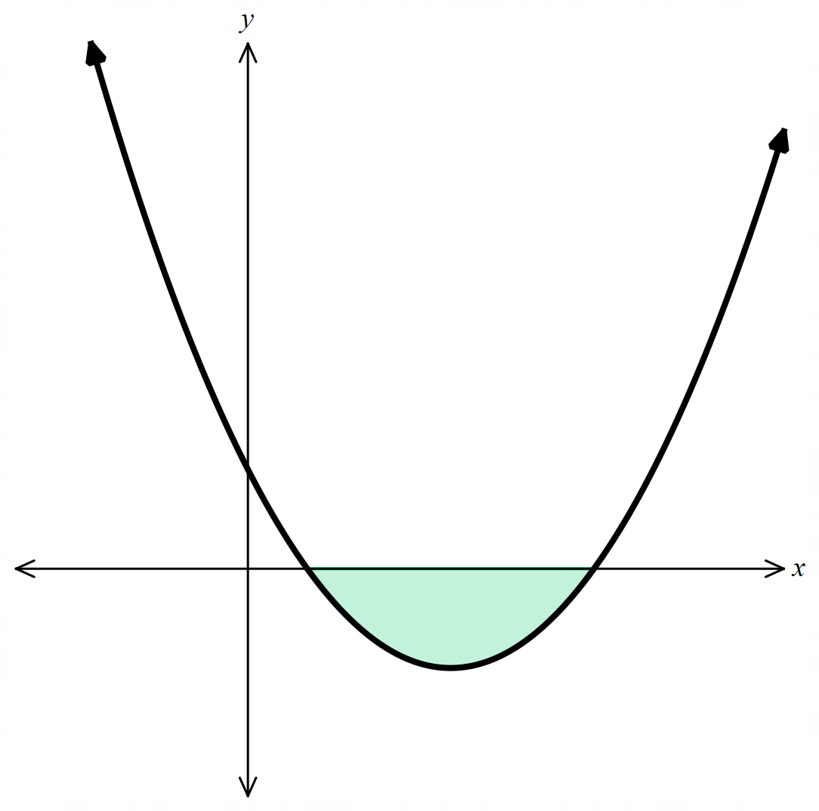  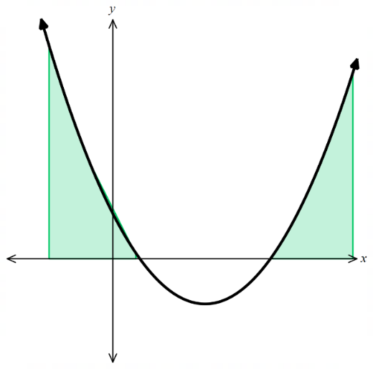  Negative Area

- Example Interpret the sign of an integral
$$\int_{0}^{3}{\left(2x-6\right)}dx={\left[\begin{matrix} \\ x^{2}-6x \\ \end{matrix}\right]}_{0}^{3}$$
$$=\left(9-18\right)-\left(0-0\right)$$
$$=-9$$
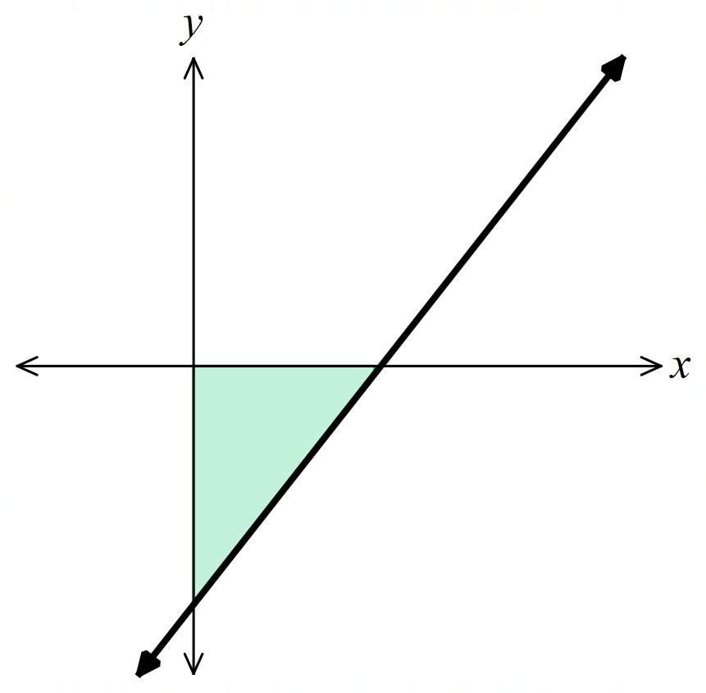

$$\int_{3}^{6}{\left(2x-6\right)}dx={\left[\begin{matrix} \\ x^{2}-6x \\ \end{matrix}\right]}_{3}^{6}$$
$$=\left(36-36\right)-\left(9-18\right)$$
$$=9$$
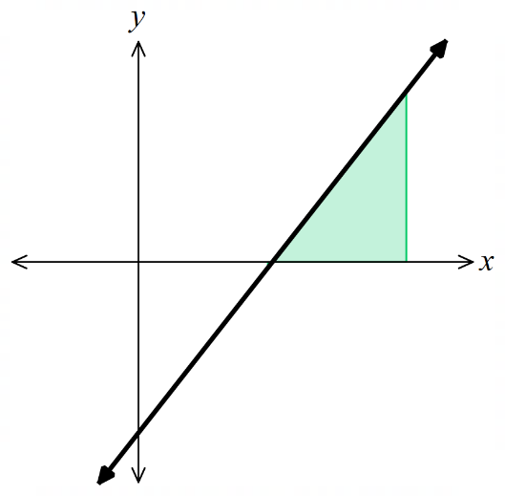

$$\int_{0}^{6}{\left(2x-6\right)}dx={\left[\begin{matrix} \\ x^{2}-6x \\ \end{matrix}\right]}_{0}^{6}$$
$$=\left(36-36\right)-\left(0-0\right)$$
$$=0$$
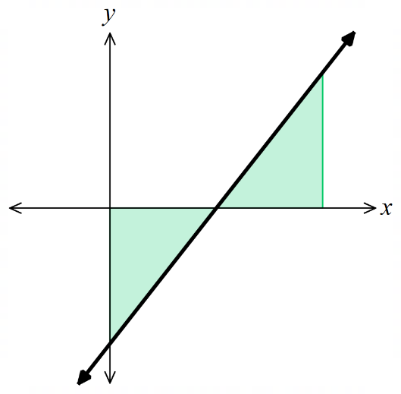

- Additive Property of Intervals
You can split a region at any intermediate point and add the subintervals.
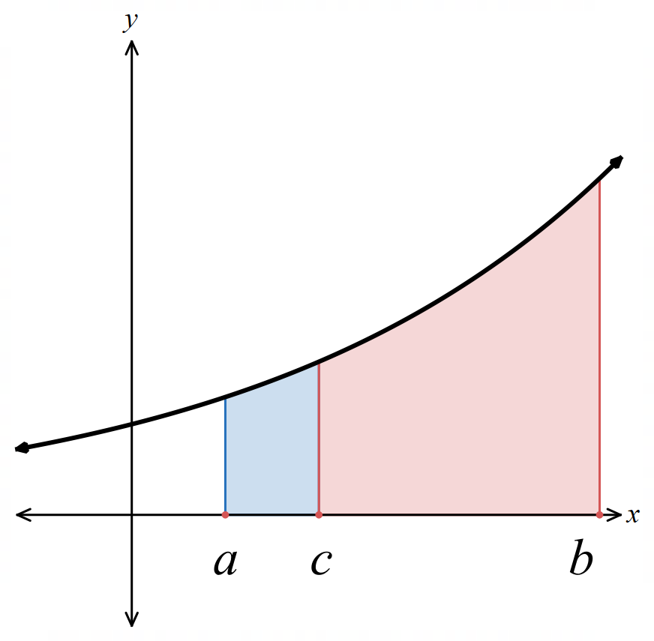
$$\int_{a}^{b}{f\left(x\right)}dx=\int_{a}^{c}{f\left(x\right)}dx+\int_{c}^{b}{f\left(x\right)}dx$$

- Apply additive property of integrals
- Given $\int_{0}^{3}{f\left(x\right)}dx = 15$and $\int_{3}^{8}{f\left(x\right)}dx = 9$, find $\int_{0}^{8}{f\left(x\right)}dx.$ | - Given $\int_{1}^{4}{f\left(x\right)}dx = 14$ and $\int_{4}^{6}{f\left(x\right)}dx = 5$, find $\int_{1}^{6}{f\left(x\right)}dx.$
- Given $\int_{2}^{7}{f\left(x\right)}dx = 10$ and $\int_{2}^{5}{f\left(x\right)}dx = 13$, find $\int_{5}^{7}{f\left(x\right)}dx.$ | - Given $\int_{0}^{4}{f\left(x\right)}dx = -6$ and $\int_{0}^{2}{f\left(x\right)}dx = 3,$ find $\int_{2}^{4}{f\left(x\right)}dx.$

- Reversal of Limits Property
Swapping the limits of integration negates the result.

$$\int_{a}^{b}{f\left(x\right)}dx=-\int_{b}^{a}{f\left(x\right)}dx$$

This is because $\left[F\left(b\right)-F\left(a\right)\right]=-\left[F\left(a\right)-F\left(b\right)\right]$

- Apply reversal of limits property of the definite integral
- Given $\int_{2}^{7}{f\left(x\right)}dx = 11$,  find $\int_{7}^{2}{f(x)} dx$. | - Given $\int_{5}^{1}{f\left(x\right)}dx = -3$,  find $\int_{1}^{5}{f\left(x\right)}dx$
- Given $\int_{0}^{6}{f\left(x\right)}dx = 20$ and $\int_{4}^{0}{f\left(x\right)}dx = -9$,  find $\int_{4}^{6}{f(x)} dx$. | - Given $\int_{3}^{7}{f\left(x\right)}dx=5$ and  $\int_{0}^{7}{f(x)} dx = 18$,  Find $\int_{3}^{0}{f\left(x\right)}dx$

- The Definite Integral and Symmetries
For an odd function, the area above the  $x$-axis on one side is exactly cancelled by the area below on the other side.  $$\int_{-a}^{a}{f\left(x\right)}dx=0$$  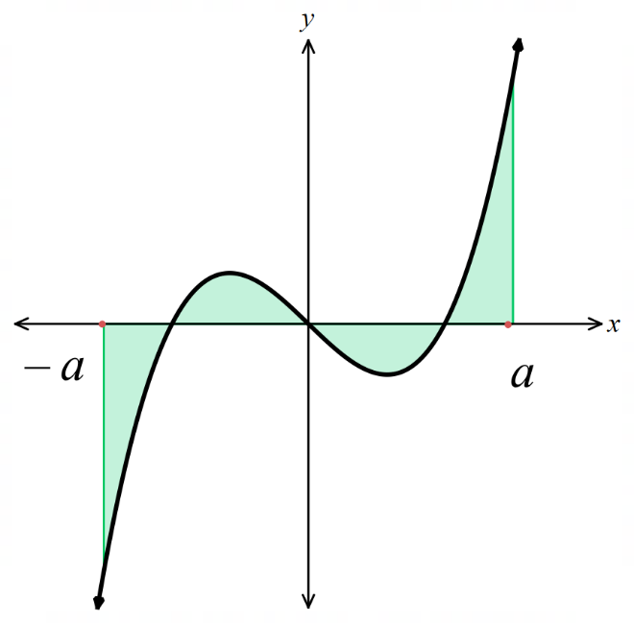 | 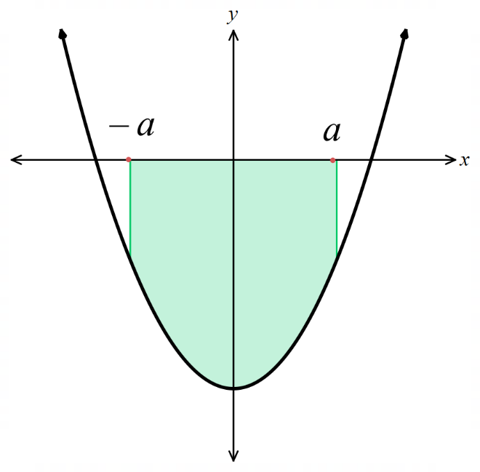  For an even function, the area from $-a$ to $0$ is identical to the area from $0$ to $a$.  You can evaluate one half and double it.  $$\int_{-a}^{a}{f\left(x\right)}dx=2\int_{0}^{a}{f\left(x\right)}dx$$

- Apply symmetry properties of the definite integral
- Given $f(x)$ is even and $\int_{0}^{3}{f\left(x\right)}dx = 8$,  find $\int_{-3}^{3}{f\left(x\right)}dx.$ | - Given $g\left(x\right)$ is odd and  $\int_{0}^{5}{g\left(x\right)}dx = 8$,  find $\int_{-5}^{5}{g\left(x\right)}dx.$
- Given $f(x)$ is even and  $\int_{-2}^{2}{f\left(x\right)}dx = 14$,  find $\int_{0}^{2}{f\left(x\right)}dx.$ | - Given $g(x)$ is odd and  $\int_{-2}^{5}{g\left(x\right)}dx = 8$,  find $\int_{2}^{5}{g\left(x\right)}dx.$

- The Definite Integral and Symmetries
When the limits of an integral are from $-a$ to $a$, check whether the function is odd or even.

- Also test whether you are integrating across an asymptote.

For an odd function:  $$\int_{-a}^{a}{f\left(x\right)}dx=0$$ | For an even function:  $$\int_{-a}^{a}{f\left(x\right)}dx=2\int_{0}^{a}{f\left(x\right)}dx$$

- Example Integrate using symmetry properties of the definite integral
$$\int_{-2}^{2}{\left(x^{3}-4x\right)}dx$$  This is an odd function.  $$\int_{-2}^{2}{\left(x^{3}-4x\right)}dx=0$$ | $$\int_{-2}^{2}{\left(x^{2}+1\right)}dx$$  This is an even function.  $$2\int_{0}^{2}{\left(x^{2}+1\right)}dx$$  $$={2\left[\frac{x^{3}}{3}+x\right]}_{0}^{2}$$  $$=2\left(\left(\frac{8}{3}+2 \right)-\left(0+0\right)\right)$$  $$=\frac{28}{3}$$

- Guided Practice
$$\int_{-2}^{2}{(x^{4}+x^{2}+3)}dx$$  $$\frac{452}{15}$$ | $$\int_{-2}^{2}{ \frac{7}{x} }dx$$  undefined
$$\int_{-5}^{5}{\left(\sin{x}+xe^{x^{2}}\right)}dx$$  0 | $$\int_{-\frac{π}{3}}^{\frac{π}{3}}{\tan{x}}dx$$  0
- Integral of a Sum or Difference of Functions
You can break a complicated integrand into simpler pieces and integrate each separately.
Useful when integrating a sum of an even and odd function and the limits are symmetric.
$$\int_{a}^{b}{\left(f\left(x\right)+g\left(x\right)\right)}dx=\int_{a}^{b}{f\left(x\right)}dx+\int_{a}^{b}{g\left(x\right)}dx$$
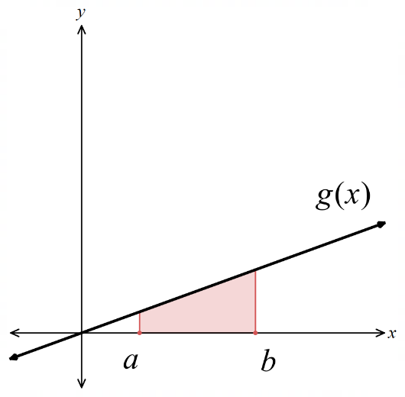
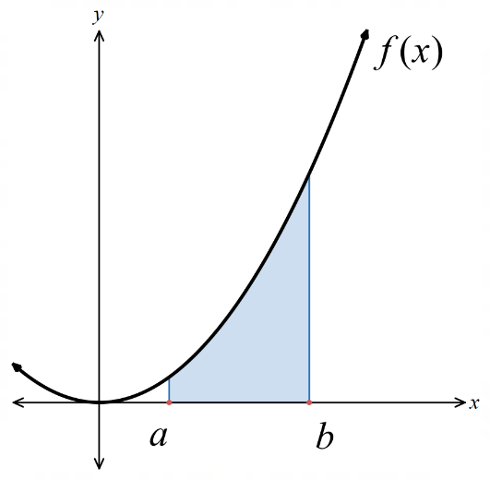
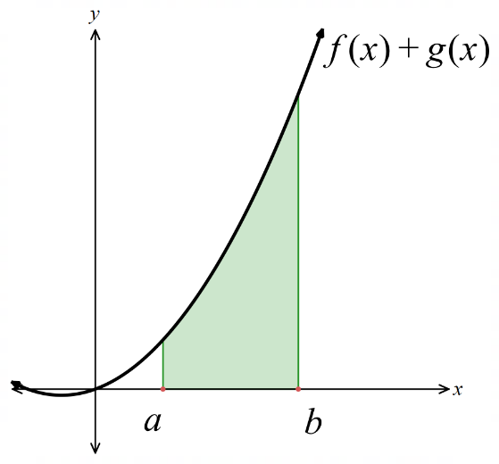

- Example Integrate sums or differences of functions using reverse chain rule
$$\int_{-3}^{3}{\left(x^{4}+x^{3}\right)}dx=\int_{-3}^{3}{x^{4}}dx+\int_{-3}^{3}{x^{3}}dx$$
$$=2\int_{0}^{3}{x^{4}}dx+0 because x^{4} is even and x^{3} is odd$$
$$=2{\left[\frac{x^{5}}{5}\right]}_{0}^{3}$$
$$=2\left(\frac{243}{5}-0\right)$$
$$=\frac{486}{5}$$

- Guided Practice
$$\int_{-2}^{2}{x^{2}+x^{5}}dx$$  $$\frac{16}{3}$$ | $$\int_{-\frac{π}{2}}^{\frac{π}{2}}{\left(\sin{2x}+\cos{\frac{x}{3}}\right)}dx$$  $$3$$

Foundation
- Evaluate $\int_{4}^{5}{\left(2x - 3\right)dx}$ and $\int_{5}^{4}{\left(2x - 3\right)dx}$. What do you notice?

$$\int_{4}^{5}{\left(2x - 3\right)dx}= {\left[x^{2}- 3x\right]}_{4}^{5}= \left(25 - 15\right)- \left(16 - 12\right)= 6$$
$$\int_{5}^{4}{\left(2x - 3\right)dx}= {\left[x^{2}- 3x\right]}_{5}^{4}= \left(16 - 12\right)- \left(25 - 15\right)= -6$$
The values are 6 and −6. Reversing the limits changes the sign.
- Show, by evaluating the definite integrals, that:
  - $\int_{0}^{1}{6x^{2}dx}= 6\int_{0}^{1}{x^{2}dx}$
$$LHS: \int_{0}^{1}{6x^{2}dx}= {\left[2x^{3}\right]}_{0}^{1}= 2$$
$$RHS: 6\int_{0}^{1}{x^{2}dx}= 6{\left[\frac{x^{3}}{3}\right]}_{0}^{1}= 6\left(\frac{1}{3}\right)= 2$$
$$LHS = RHS = 2$$

  - $\int_{-1}^{2}{\left(x^{3}+ x^{2}\right)dx} = \int_{-1}^{2}{x^{3}dx}+ \int_{-1}^{2}{x^{2}dx}$

$$LHS: \int_{-1}^{2}{\left(x^{3}+ x^{2}\right)dx}= \left[\frac{x^{4}}{4}+\frac{x^{3}}{3}\right]-1^{2}= \left(4 +\frac{8}{3}\right)- \left(\frac{1}{4}-\frac{1}{3}\right)=\frac{27}{4}$$
$$RHS: \int_{-1}^{2}{x^{3}dx}+ \int_{-1}^{2}{x^{2}dx}= \left[\frac{x^{4}}{4}\right]-1^{2}+ {\left[\frac{x^{3}}{3}\right]}_{-1}^{2}= \left(4 -\frac{1}{4}\right)+ \left(\frac{8}{3}+\frac{1}{3}\right)=\frac{15}{4}+ 3 =\frac{27}{4}$$
$$LHS = RHS =\frac{27}{4}$$
  - $\int_{0}^{3}{\left(x^{2}- 4x + 3\right)dx}= \int_{0}^{2}{\left(x^{2}- 4x + 3\right)dx}+ \int_{2}^{3}{\left(x^{2}- 4x + 3\right)dx}$
$$LHS: \int_{0}^{3}{\left(x^{2}- 4x + 3\right)dx}= {\left[\frac{x^{3}}{3}- 2x^{2}+ 3x\right]}_{0}^{3}= \left(9 - 18 + 9\right)- 0 = 0$$
$$RHS: \int_{0}^{2}{\left(x^{2}- 4x + 3\right)dx}+ \int_{2}^{3}{\left(x^{2}- 4x + 3\right)dx}$$
$$= {\left[\frac{x^{3}}{3}- 2x^{2}+ 3x\right]}_{0}^{2}+ {\left[\frac{x^{3}}{3}- 2x^{2}+ 3x\right]}_{2}^{3}$$
$$= \left(\frac{8}{3}- 8 + 6\right)+ \left(\left(9 - 18 + 9\right)- \left(\frac{8}{3}- 8 + 6\right)\right)$$
$$= 0$$
$$LHS = RHS = 0$$

- Without evaluating the definite integrals, explain why:
- $\int_{2}^{2}{\left(x^{2}- 3x\right)dx}= 0$  The upper and lower limits are equal, so the interval has zero width. Therefore $\int_{2}^{2}{\left(x^{2}- 3x\right)dx}= 0.$ | - $\int_{-2}^{2}{x}dx = 0$  $y = x$ is an odd function, so the areas above and below the $x$-axis on [−2, 2] cancel. Therefore $\int_{-2}^{2}{x}dx = 0$
- The diagram shows the line $y = x - 1$.
Without evaluating the definite integrals, explain why:
- $\int_{0}^{1}{\left(x - 1\right) dx}$ is negative  On [0, 1], the line $y = x - 1$ lies below the $x$-axis.  The integral is negative. | 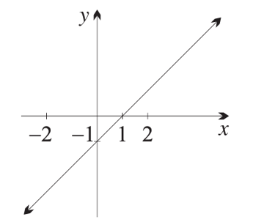  .
- $\int_{1}^{2}{\left(x - 1\right)}$ $dx$ is positive

On $[1, 2],$ the line $y = x - 1$ lies above the $x$-axis.
The integral is positive
- $\int_{0}^{2}{\left(x - 1\right)}$ $dx$ is zero  On [0, 1] the line is below the x-axis, on [1, 2] it is above.  The two triangles have equal area (both base 1, height 1), so the signed areas cancel. The integral is zero. | - $\int_{-2}^{2}{\left(x - 1\right)}$ $dx$ is negative  On [−2, 1] the line is below the $x$-axis  On [1, 2] it is above  The negative area exceeds the positive area.  The integral is negative.

- The diagram shows the parabola $y = 1 - x².$
Without evaluating the definite integrals, explain why:
- $\int_{-1}^{1}{\left(1 - x^{2}\right)dx}$ is positive  On [−1, 1], the parabola is above the x-axis. The integral is positive. | 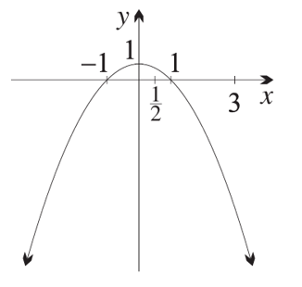
- $\int_{1}^{3}{\left(1 - x^{2}\right)dx}$ is negative

On [1, 3], the parabola is below the x-axis. The integral is negative.
- $\int_{-1}^{0}{\left(1 - x^{2}\right)dx}= \int_{0}^{1}{\left(1 - x^{2}\right)dx}$  $y = 1 - x²$ is an even function,  so it is symmetrical about the y-axis.  The area from −1 to 0 equals the area from 0 to 1. | - $\int_{0}^{\frac{1}{2}}{\left(1 - x^{2}\right)dx} > \int_{\frac{1}{2}}^{1}{\left(1 - x^{2}\right)}dx$  On [0, 1], the curve y = 1 − x² is positive and decreasing.  The curve is higher on [0, 1/2] than on [1/2, 1], so the area under the parabola from 0 to 1/2 is greater than the area from 1/2 to 1.

  - If $\int_{1}^{3}{f\left(x\right)dx}= 7$, then what is the value of $\int_{3}^{1}{f\left(x\right)dx}$?

Reversing the limits changes the sign. $-7$
  - If $\int_{2}^{1}{g\left(x\right)dx}= -5$, then what is the value of $\int_{1}^{2}{g\left(x\right)dx}$?

Reversing the limits changes the sign. 5

Development
- In each part, evaluate the definite integrals.
Then use the properties of the definite integral to explain the relationship.
- $\int_{0}^{2}{\left(3x^{2}- 1\right)dx}$  $$\int_{0}^{2}{\left(3x^{2}- 1\right)dx}= {\left[x^{3}- x\right]}_{0}^{2}= \left(8 - 2\right)- 0 = 6$$ | - $\int_{2}^{0}{\left(3x^{2}- 1\right)dx}$  $$\int_{2}^{0}{\left(3x^{2}- 1\right)dx}= {\left[x^{3}- x\right]}_{2}^{0}= 0 - \left(8 - 2\right)= -6$$  The integrals are opposites because the limits have been reversed.
- $\int_{0}^{1}{20x^{3}dx}$  $$\int_{0}^{1}{20x^{3}dx}= {\left[5x^{4}\right]}_{0}^{1}= 5$$ | - $20\int_{0}^{1}{x^{3}dx}$  $$20\int_{0}^{1}{x^{3}dx}= 20{\left[\frac{x^{4}}{4}\right]}_{0}^{1}= 20\left(\frac{1}{4}\right)= 5$$  A constant factor can be taken out of the integral.
- $\int_{1}^{4}{\left(4x + 5\right)dx}$  $$\int_{1}^{4}{\left(4x + 5\right)dx}= {\left[2x^{2}+ 5x\right]}_{1}^{4}$$  $$= \left(32 + 20\right)- \left(2 + 5\right)$$  $$= 45$$ | - $\int_{1}^{4}{4x}dx$  $$\int_{1}^{4}{4x}dx = {\left[2x^{2}\right]}_{1}^{4}$$  $$= 32 - 2$$  $$= 30$$ | - $\int_{1}^{4}{5}dx$  $$\int_{1}^{4}{5}dx = {\left[5x\right]}_{1}^{4}$$  $$= 20 - 5$$  $$= 15$$  An integral of a sum is the sum of the integrals.
- $\int_{0}^{2}{12x^{3}dx}$  $$\int_{0}^{2}{12x^{3}dx}= {\left[3x^{4}\right]}_{0}^{2}$$  $$= 48$$ | - $\int_{0}^{1}{12x^{3}dx}$  $$\int_{0}^{1}{12x^{3}dx}= {\left[3x^{4}\right]}_{0}^{1}$$  $$= 3$$ | - $\int_{1}^{2}{12x^{3}dx}$  $$\int_{1}^{2}{12x^{3}dx}= {\left[3x^{4}\right]}_{1}^{2}= 48 - 3 = 45$$  The interval [0, 2] can be split into [0, 1] and [1, 2].

- Use the properties of the definite integral to evaluate each integral without using a primitive function. Give reasons.
- $\int_{3}^{3}{\sqrt{9 - x^{2}}}dx$  0. The interval has zero width (both limits are 3). | - $\int_{4}^{4}{\left(x^{3}- 3x^{2}+ 5x - 7\right)dx}$  0. The interval has zero width (both limits are 4).
- $\int_{-1}^{1}{x^{3}dx}$  0. Integrand is an odd function and the interval [−1, 1] is symmetric about the origin. | - $\int_{-5}^{5}{\left(x^{3}- 25x\right)dx}$  0. Integrand is odd and the interval [−5, 5] is symmetric about the origin.
- $\int_{-\frac{π}{2}}^{\frac{π}{2}}{sin}x dx$  0. $f(x) = sin x$ is an odd function and the interval $\left[-\frac{π}{2},\frac{π}{2}\right]$ is symmetric about the origin. | - $\int_{-2}^{2}{\frac{x}{1 + x^{2}}}dx$  0. Integrand is odd (numerator is odd, denominator is even) and the interval [−2, 2] is symmetric about the origin.
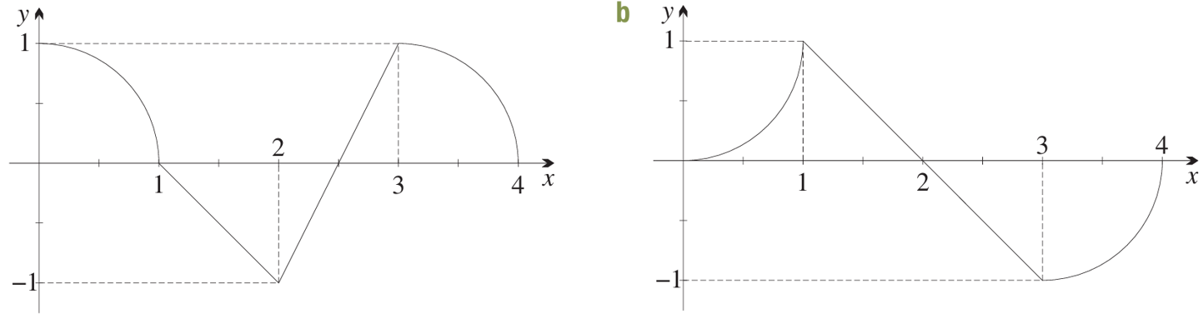
- Use area formulae to find $\int_{0}^{4}{f\left(x\right)dx}$, given the following sketches of $f(x).$
$$\frac{π}{2}-\frac{1}{2}$$ | $$1-\frac{π}{2}$$

  - Calculate these definite integrals using graphs and area formulae.
- $\int_{-\frac{1}{4}}^{\frac{1}{4}}{\left(1 - 4x\right)dx}$  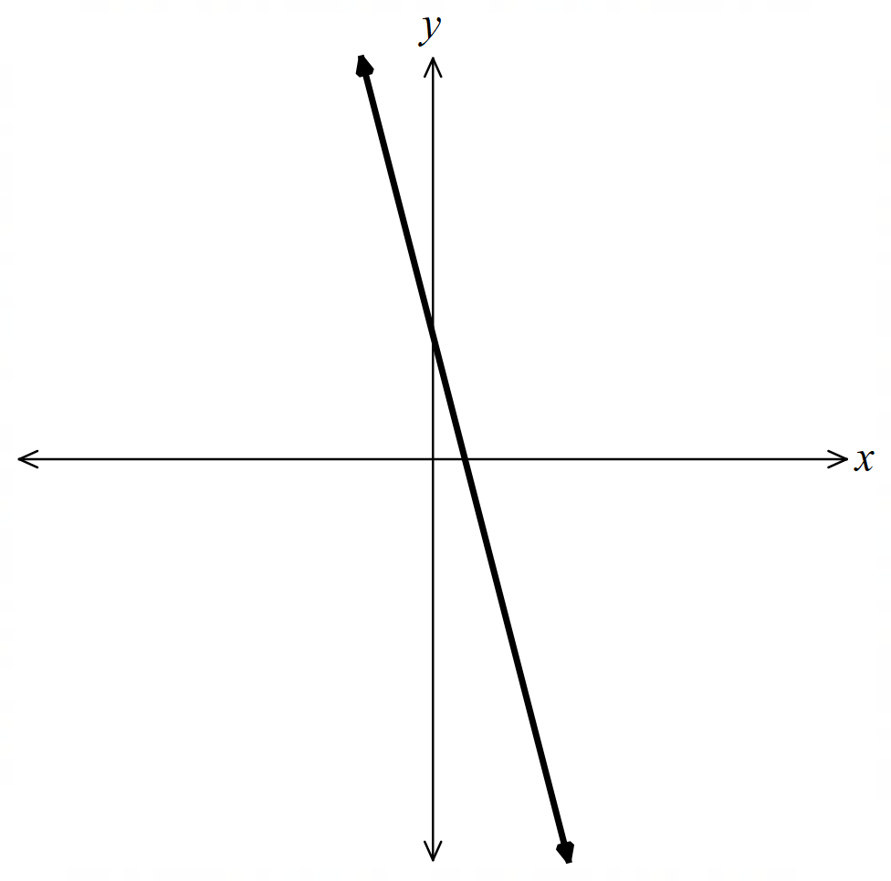  $$\frac{1}{2}$$ | - $\int_{-5}^{1}{\left|x + 5\right|dx}$  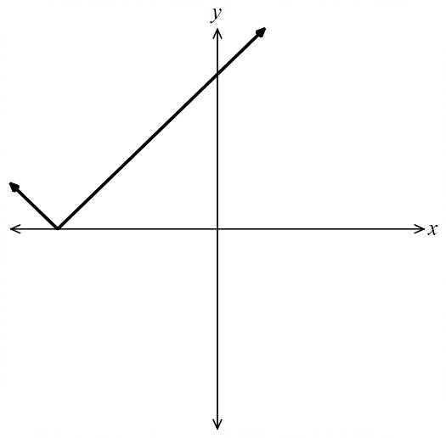  $$18$$ | - $\int_{0}^{2}{\left(\left|x\right|+ 3\right)dx}$  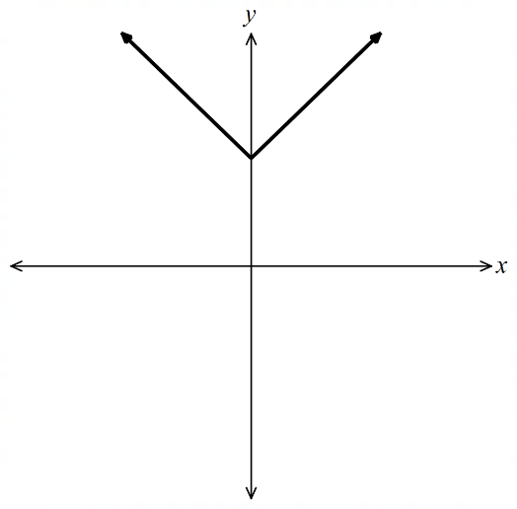  $$8$$

  - Hence write down the value of:
- $\int_{\frac{1}{4}}^{-\frac{1}{4}}{\left(1 - 4x\right)dx}$  $$-\frac{1}{2}$$ | - $\int_{1}^{-5}{\left|x + 5\right|dx}$  $$-18$$ | - $\int_{2}^{0}{\left(\left|x\right|+ 3\right)dx}$  $$-8$$

Integrating Exponential Functions

- Review
- Differentiate these functions.
- $f\left(x\right)=4e^{x}$ | - $f\left(x\right)=4e^{3x}$ | - $f\left(x\right)=4e^{3x+1}$

- Integrate exponential functions
$$f\left(x\right)=3e^{2x+5}$$  Differentiate multiply by $2$  $$f^{'}\left(x\right)=6e^{2x+5}$$ |  |  | $$f\left(x\right)=\frac{6}{2}e^{2x+5}+C$$  Integrate divide by $2$  $$f^{'}\left(x\right)=6e^{2x+5}$$
$$\int{5e^{x}}dx$$  $$=5e^{x}+C$$ | $$\int{5e^{7x}}dx$$  $$=\frac{5}{7}e^{7x}+C$$ |  | $$\int{3e^{7x}}dx$$  $$=\frac{3}{7}e^{7x}+C$$ |  | $$\int{3e^{11x}}dx$$  $$=\frac{3}{11}e^{11x}+C$$
Find the indefinite integral of the following:
$$\int{5e^{x}}dx$$ |  | $$\int{5e^{7x}}dx$$ |  | $$\int{3e^{7x}}dx$$
$$\int{3e^{11x}}dx$$ |  | $$\int{3e^{11x-4}}dx$$ |  | $$\int{-\frac{e^{2-5x}}{7}}dx$$

- Integrating Exponential Functions of Base $e$
$$\int{e^{x}}dx=e^{x}+C \\ \int{e^{ax+b}}dx=\frac{e^{ax+b}}{a}+C$$

- Example Integrate exponential functions
$$\int{e^{2x}}+e^{-x} dx$$  $$=\frac{e^{2x}}{2}+\frac{e^{-x}}{-1}+C$$  $$=\frac{e^{2x}}{2}-\frac{1}{e^{x}}+C$$ | $$\int_{2}^{3}{e^{5-2x}} dx$$  $$={\left[-\frac{1}{2}e^{5-2x}\right]}_{2}^{3}$$  $$=-\frac{1}{2}\left(e^{-1}-e^{1}\right)$$  $$=-\frac{1}{2}\left(\frac{1}{e}-e\right)$$  $$=\frac{e^{2}-1}{2e}$$

- Guided Practice
$$\int{\frac{e^{x}}{3}-e^{5x-2}}dx$$  $$\frac{e^{x}}{3}-\frac{e^{5x-2}}{5}+C$$ | $$\int_{-1}^{3}{4e^{\frac{x}{5}}}dx$$  $$20\left(e^{\frac{3}{5}}-e^{-\frac{1}{5}}\right)$$

Foundation
- Find the indefinite integral.
- $\int{e^{2x}}dx$  $$\left(\frac{1}{2}\right)e^{2x}+ C$$ | - $\int{e^{3x}}dx$  $$\left(\frac{1}{3}\right)e^{3x}+ C$$ | - $\int{e^{\frac{x}{3}}}dx$  $$3e^{\frac{x}{3}}+ C$$ | - $\int{e^{\frac{x}{2}}}dx$  $$2e^{\frac{x}{2}}+ C$$
- $\int{10e^{2x}}dx$  $$5e^{2x}+ C$$ | - $\int{12e^{3x}}dx$  $$4e^{3x}+ C$$ | - $\int{e^{4x+5}}dx$  $$\left(\frac{1}{4}\right)e^{4x+5}+ C$$ | - $\int{e^{4x-2}}dx$  $$\left(\frac{1}{4}\right)e^{4x-2}+ C$$
- $\int{6e^{3x+2}}dx$  $$2e^{3x+2}+ C$$ | - $\int{4e^{4x+3}}dx$  $$e^{4x+3}+ C$$ | - $\int{e^{7-2x}}dx$  $$-\left(\frac{1}{2}\right)e^{7-2x}+ C$$ | - $\int{\frac{1}{2}}e^{1-3x}dx$  $$-\left(\frac{1}{6}\right)e^{1-3x}+ C$$

- Evaluate these definite integrals.
- $\int_{0}^{1}{e^{x}}dx$  $$e - 1$$ | - $\int_{1}^{2}{e^{x}}dx$  $$e^{2}- e$$ | - $\int_{-1}^{3}{e^{-x}}dx$  $$e - e^{-3}$$ | - $\int_{-2}^{0}{e^{-x}}dx$  $$e^{2}- 1$$
- $\int_{0}^{2}{e^{2x}}dx$  $$\left(\frac{1}{2}\right)\left(e^{4}- 1\right)$$ | - $\int_{-1}^{2}{20e^{-5x}}dx$  $$4\left(e^{5}- e^{-10}\right)$$ | - $\int_{-3}^{1}{8e^{-4x}}dx$  $$2\left(e^{12}- e^{-4}\right)$$ | - $\int_{-1}^{3}{9e^{6x}}dx$  $$\left(\frac{3}{2}\right)\left(e^{18}- e^{-6}\right)$$
- $\int_{-1}^{1}{e^{2x+1}}dx$  $$\left(\frac{1}{2}\right)\left(e^{3}- e^{-1}\right)$$ | - $\int_{-2}^{0}{e^{4x-3}}dx$  $$\left(\frac{1}{4}\right)\left(e^{-3}- e^{-11}\right)$$ | - $\int_{-2}^{-1}{e^{3x+2}}dx$  $$\left(\frac{1}{3}\right)\left(e^{-1}- e^{-4}\right)$$ | - $\int_{-\frac{1}{2}}^{\frac{1}{2}}{e^{3-2x}}dx$  $$\left(\frac{e^{2}}{2}\right)\left(e^{2}- 1\right)$$
- $\int_{-\frac{1}{3}}^{\frac{1}{3}}{e^{2+3x}}dx$  $$\left(\frac{e}{3}\right)\left(e^{2}- 1\right)$$ | - $\int_{1}^{2}{6e^{3x+1}}dx$  $$2e^{4}\left(e^{3}- 1\right)$$ | - $\int_{2}^{3}{12e^{4x-5}}dx$  $$3e^{3}\left(e^{4}- 1\right)$$ | - $\int_{1}^{2}{12e^{8-3x}}dx$  $$4e^{2}\left(e^{3}- 1\right)$$

- Find the indefinite integral of each function.
- $∫\frac{1}{e^{x}}$ $dx$  $$-e^{-x}+ C$$ | - $∫\frac{1}{e^{2x}}$ $dx$  $$-\left(\frac{1}{2}\right)e^{-2x}+ C$$ | - $∫\frac{1}{e^{3x}}$ $dx$  $$-\left(\frac{1}{3}\right)e^{-3x}+ C$$
- $-∫\frac{3}{e^{3x}}$ $dx$  $$e^{-3x}+ C$$ | - $∫\frac{6}{e^{2x}}$ $dx$  $$-3e^{-2x}+ C$$ | - $∫\frac{8}{e^{-2x}}$ $dx$  $$4e^{2x}+ C$$

  - A function $f(x)$ has derivative $f'(x) = e^{2x}$.
Find the equation of $f(x),$ which will involve an arbitrary constant.

$$\left(\frac{1}{2}\right)e^{2x}+ C$$
  - It is also known that $f(0) = -2$.
Find the arbitrary constant and hence write down the equation of $f(x)$.

$$f\left(x\right)= \left(\frac{1}{2}\right)e^{2x}-\frac{5}{2}$$
  - Find $f(1)$ and $f(2)$.

$$f\left(1\right)= \left(\frac{1}{2}\right)e^{2}-\frac{5}{2}$$
$$f\left(2\right)= \left(\frac{1}{2}\right)e^{4}-\frac{5}{2}$$
- Find the indefinite integral of:
- $\int{e^{x}\left(e^{x}+ 1\right)}dx$  $$\left(\frac{1}{2}\right)e^{2x}+ e^{x}+ C$$ | - $\int{e^{-x}\left(2e^{-x}- 1\right)}dx$  $$e^{-x}- e^{-2x}+ C$$ | - $\int{{\left(e^{x}- 1\right)}^{2}}dx$  $$\left(\frac{1}{2}\right)e^{2x}- 2e^{x}+ x + C$$

Development
- Find $f(x)$ and then find $f(1)$, given that:
  - $f'(x) = 1 + 2e^{x}$ and $f(0) = 1$
$$f\left(x\right)= x + 2e^{x}+ C$$
$$f\left(0\right)= 1: 0 + 2 + C = 1, C = -1$$
$$f\left(x\right)= x + 2e^{x}- 1, f\left(1\right)= 1 + 2e - 1 = 2e$$
  - $f'(x) = e^{2x-1}$ and $f\left(\frac{1}{2}\right)= 3$
$$f\left(x\right)= \left(\frac{1}{2}\right)e^{2x-1}+ C$$
$$f\left(\frac{1}{2}\right)= 3: \left(\frac{1}{2}\right)e^{0}+ C = 3, C =\frac{5}{2}$$
$$f\left(x\right)= \left(\frac{1}{2}\right)e^{2x-1}+\frac{5}{2}, f\left(1\right)= \left(\frac{1}{2}\right)\left(e + 5\right)$$
  - $f'(x) = e^{\frac{x}{2}+1}$ and $f(-2) = -4$

$$f\left(x\right)= 2e^{\frac{x}{2}+1}+ C$$
$$f\left(-2\right)= -4: 2e^{0}+ C = -4, C = -6$$
$$f\left(x\right)= 2e^{\frac{x}{2}+1}- 6, f\left(1\right)= 2e^{\frac{3}{2}}- 6$$

- Find the indefinite integral of:
- $\int{e^{7x+q}}dx$  $$\left(\frac{1}{7}\right)e^{7x+q}+ C$$ | - $\int{e^{3x-k}}dx$  $$\left(\frac{1}{3}\right)e^{3x-k}+ C$$ | - $\int{e^{sx+1}}dx$  $$\left(\frac{1}{s}\right)e^{sx+1}+ C$$ | - $\int{e^{kx-1}}dx$  $$\left(\frac{1}{k}\right)e^{kx-1}+ C$$
- $\int{pe^{px+q}}dx$  $$e^{px+q}+ C$$ | - $\int{me^{mx+k}}dx$  $$e^{mx+k}+ C$$ | - $\int{Ae^{sx-t}}dx$  $$\left(\frac{A}{s}\right)e^{sx-t}+ C$$ | - $\int{Be^{kx-l}}dx$  $$\left(\frac{B}{k}\right)e^{kx-l}+ C$$

- Find the indefinite integral of:
- $\int{\frac{1}{e^{x-1}}}$ $dx$  $$-e^{1-x}+ C$$ | - $\int{\frac{1}{e^{3x-1}}}$ $dx$  $$-\left(\frac{1}{3}\right)e^{1-3x}+ C$$ | - $\int{\frac{1}{e^{2x+5}}}$ $dx$  $$-\left(\frac{1}{2}\right)e^{-2x-5}+ C$$
- $\int{\frac{4}{e^{2x-1}}}$ $dx$  $$-2e^{1-2x}+ C$$ | - $\int{\frac{10}{e^{2-5x}}}$ $dx$  $$2e^{5x-2}+ C$$ | - $\int{\frac{12}{e^{3x-5}}}$ $dx$  $$-4e^{5-3x}+ C$$
- By writing each integrand as the sum of multiples of powers of $e$, find:
- $\int{\frac{e^{x}+ 1}{e^{x}}}$ $dx$  $$x - e^{-x}+ C$$ | - $\int{\frac{e^{2x}+ 1}{e^{x}}}$ $dx$  $$e^{x}- e^{-x}+ C$$ | - $\int{\frac{e^{x}- 1}{e^{2x}}}$ $dx$  $$\left(\frac{1}{2}\right)e^{-2x}- e^{-x}+ C$$
- $\int{\frac{e^{x}- 3}{e^{3x}}}$ $dx$  $$e^{-3x}- \left(\frac{1}{2}\right)e^{-2x}+ C$$ | - $\int{\frac{2e^{2x}- 3e^{x}}{e^{4x}}}$ $dx$  $$e^{-3x}- e^{-2x}+ C$$ | - $\int{\frac{2e^{x}- e^{2x}}{e^{3x}}}$ $dx$  $$e^{-x}- e^{-2x}+ C$$

- Evaluate:
- $\int_{0}^{1}{e^{x}\left(2e^{x}- 1\right)}dx$  $$e^{2}- e$$ | - $\int_{-1}^{1}{{\left(e^{x}+ 2\right)}^{2}}dx$  $$\left(\frac{1}{2}\right)\left(e^{2}- e^{-2}\right)+ 4\left(e - e^{-1}\right)+ 8$$ | - $\int_{0}^{1}{\left(e^{x}- 1\right)\left(e^{-x}+ 1\right)}dx$  $$e + e^{-1}- 2$$
- $\int_{-1}^{1}{\left(e^{2x}+e^{-x}\right)\left(e^{2x}-e^{-x}\right)}$ $dx$  $$\left(\frac{1}{4}\right)\left(e^{4}- e^{-4}\right)+ \left(\frac{1}{2}\right)\left(e^{-2}- e^{2}\right)$$ | - $\int_{0}^{1}{\frac{e^{3x}+ e^{x}}{e^{2x}}}$ $dx$  $$e - e^{-1}$$ | - $\int_{-1}^{1}{\frac{e^{x}- 1}{e^{2x}}}$ $dx$  $$e - e^{-1}+ \left(\frac{1}{2}\right)\left(e^{-2}- e^{2}\right)$$

Mastery
- Write each integrand as a power of $e$, and hence find the indefinite integral.
- $\int{\frac{1}{{\left(e^{x}\right)}^{2}}}$ $dx$  $$-\left(\frac{1}{2}\right)e^{-2x}+ C$$ | - $\int{\frac{1}{{\left(e^{x}\right)}^{3}}}$ $dx$  $$-\left(\frac{1}{3}\right)e^{-3x}+ C$$ | - $\int{\sqrt{e^{x}}}$ $dx$  $$2e^{\frac{x}{2}}+ C$$
- $\int{\sqrt[3]{e^{x}}}dx$  $$3e^{\frac{x}{3}}+ C$$ | - $\int{\frac{1}{\sqrt{e^{x}}}}$ $dx$  $$-2e^{-\frac{x}{2}}+ C$$ | - $\int{\frac{1}{\sqrt[3]{e^{x}}}}$ $dx$  $$-3e^{-\frac{x}{3}}+ C$$

  - Find $y$ as a function of $x$ if $y' = e^{x-1}$, and $y = 1$ when $x = 1$.
What is the $y$-intercept of this curve?
$$y = \int{e^{x-1}}dx = e^{x-1}+ C$$
$$y\left(1\right)= 1: e^{0}+ C = 1$$
$$C = 0$$
$$y = e^{x-1}$$
$$y\left(0\right)= e^{-1}$$
  - The gradient of a curve is given by $y' = e^{2-x}$, and the curve passes through the point $(0, 1)$. What is the equation of this curve? What is its horizontal asymptote?
$$y = \int{e^{2-x}}dx = -e^{2-x}+ C$$
$$y\left(0\right)= 1: -e^{2}+ C = 1$$
$$C = e^{2}+ 1$$
$$y = e² + 1 - e^{2-x}$$
$$Horizontal asymptote: as x →∞, e^{2-x}→ 0, so y = e^{2}+ 1$$
  - It is known that$f^{'}\left(x\right)= e^{x}+$ $\frac{1}{e}$ and that $f\left(-1\right)= -1$. Find $f\left(0\right).$
$$f\left(x\right)= \int{\left(e^{x}+\frac{1}{e}\right)}dx = e^{x}+\frac{x}{e}+ C$$
$$f\left(-1\right)= e^{-1}+\frac{-1}{e}+ C = -1, C = -1$$
$$f\left(x\right)= e^{x}+\frac{x}{e}- 1$$
$$f\left(0\right)= 1 + 0 - 1 = 0$$
  - Given that $f^{''}\left(x\right)= e^{x}- e^{-x}$ and that $y = f\left(x\right)$ is horizontal as it passes through the origin, find $f\left(x\right).$
$$f''(x) = e^x - e^{-x}$$
$$f^{'}\left(x\right)= e^{x}+ e^{-x}+ C_{1}$$
$$Horizontal at origin means f^{'}\left(0\right)= 0: 1 + 1 + C_{1}= 0, C_{1}= -2$$
$$f^{'}\left(x\right)= e^{x}+ e^{-x}- 2$$
$$f\left(x\right)= e^{x}- e^{-x}- 2x + C_{2}$$
$$f\left(0\right)= 0: 1 - 1 - 0 + C_{2} = 0, C_{2} = 0$$
$$f\left(x\right)= e^{x}- e^{-x}- 2x$$

Integrating Reciprocal Functions

- Review
- Differentiate these functions.
- $f\left(x\right)=\ln\left(x\right)$ | - $f\left(x\right)=2\ln\left(3x\right)$ | - $f\left(x\right)=\ln\left(5-3x\right)$ | - $f\left(x\right)=\ln\left(2x\right)$

- Integrate reciprocal functions
$$f\left(x\right)=3\ln\left(2x+5\right)$$  Differentiate  $$f^{'}\left(x\right)=\frac{6}{2x+5}$$ |  |  | $$f\left(x\right)=\frac{6}{2}\ln{|2x+5|}+C$$  Integrate  $$f^{'}\left(x\right)=\frac{6}{2x+5}$$
$$\int{\frac{7}{x}}dx$$  $$=7\ln\left|x\right|+C$$ | $$\int{\frac{2}{x}}dx$$  $$=2\ln\left|x\right|+C$$ |  | $$\int{\frac{1}{2x}}dx$$  $$=\frac{1}{2}\ln\left|x\right|+C or$$  $$=\frac{1}{2}\ln\left|2x\right|+C$$ |  | $$\int{\frac{11}{2x+5}}dx$$  $$=\frac{11}{2}\ln\left|2x+5\right|+C$$
Find the indefinite integral of the following:
$$\int{\frac{8}{x}}dx$$ |  | $$\int{\frac{5}{x}}dx$$ |  | $$\int{\frac{1}{5x}}dx$$
$$\int{\frac{2}{5x+1}}dx$$ |  | $$\int{\frac{2}{1-5x}}dx$$ |  | $$\int{\frac{2}{{\left(1-5x\right)}^{2}}}dx$$

- Integrating Reciprocal Functions
$$\int{\frac{1}{x}}dx=\ln\left|x\right|+C \\ \int{\frac{1}{ax+b}}dx=\frac{1}{a}\ln\left|ax+b\right|+C$$
- We use absolute value signs because $\ln{x}$ is only defined for $x>0$.
However, the graph of $\frac{1}{x}$ exists for negative $x$-values too, so areas under the curve still exist there. $\ln\left|x\right|$ ensures the formula works for both positive and negative values of $x$.

- Example Integrate reciprocal functions
$$\int_{1}^{e}{\frac{1}{x}}dx$$  $$={\left[\begin{matrix} \\ \ln\left|x\right| \\ \end{matrix}\right]}_{1}^{e}$$  $$=\ln\left|e\right|-\ln\left|1\right|$$  $$=1-0$$  $$=1$$ | $$\int{\frac{1}{1-2x}} dx$$  $$=-\frac{1}{2}\ln\left|1-2x\right|+C$$

- Guided Practice
$$\int_{3}^{5}{\frac{1}{x-2}}dx$$  $$\ln{3}$$ | $$\int{\frac{3}{5x+7}}dx$$  $$\frac{3\ln\left|5x+7\right|}{5}+C$$
$$\int_{-5}^{-3}{\frac{1}{x}}dx$$  $$\ln{3}-\ln{5}$$ | $$\int_{e}^{e^{2}}{\frac{5}{x}}dx$$  5

Foundation
- Integrate the following reciprocal functions.
- $\int{\frac{2}{x}}$ $dx$  $$2 ln \left|x\right|+ C$$ | - $\int{\frac{1}{3x}}$ $dx$  $$\left(\frac{1}{3}\right)ln \left|x\right|+ C$$ | - $\int{\frac{4}{5x}}$ $dx$  $$\left(\frac{4}{5}\right)ln \left|x\right|+ C$$ | - $\int{\frac{3}{2x}}$ $dx$  $$\left(\frac{3}{2}\right)ln \left|x\right|+ C$$

- Find these indefinite integrals.
- $\int{\frac{1}{4x + 1}}$ $dx$  $$\left(\frac{1}{4}\right)ln \left|4x + 1\right|+ C$$ | - $\int{\frac{1}{5x - 3}}$ $dx$  $$\left(\frac{1}{5}\right)ln \left|5x - 3\right|+ C$$ | - $\int{\frac{6}{3x + 2}}$ $dx$  $$2 ln \left|3x + 2\right|+ C$$
- $\int{\frac{15}{5x + 1}}$ $dx$  $$3 ln \left|5x + 1\right|+ C$$ | - $\int{\frac{4}{4x + 3}}$ $dx$  $$ln \left|4x + 3\right|+ C$$ | - $\int{\frac{dx}{3 - x}}$  $$-ln \left|3 - x\right|+ C$$
- $\int{\frac{dx}{7 - 2x}}$  $$-\left(\frac{1}{2}\right)ln \left|7 - 2x\right|+ C$$ | - $\int{\frac{4dx}{5x - 1}}$  $$\left(\frac{4}{5}\right)ln \left|5x - 1\right|+ C$$ | - $12\int{\frac{dx}{1 - 3x}}$  $$-4 ln \left|1 - 3x\right|+ C$$

- Evaluate these definite integrals.
- $\int_{1}^{5}{\frac{1}{x}}$ $dx$  $$ln 5$$ | - $\int_{1}^{3}{\frac{1}{x}}$ $dx$  $$ln 3$$ | - $\int_{-8}^{-2}{\frac{1}{x}}$ $dx$  $$-2 ln 2$$
- $\int_{-3}^{9}{\frac{1}{x}}$ $dx$  undefined | - $\int_{1}^{4}{\frac{dx}{2x}}$  $$ln 2$$ | - $\int_{-15}^{-5}{\frac{dx}{5x}}$  $$-\left(\frac{1}{5}\right)ln 3$$

- Evaluate these definite integrals to 4 s.f.
- $\int_{0}^{1}{\frac{dx}{x + 1}}$  $$0.6931$$ | - $\int_{-7}^{-5}{\frac{dx}{x + 2}}$  $$-0.5108$$ | - $\int_{-5}^{-2}{\frac{dx}{2x + 3}}$  $$-0.9730$$
- $\int_{1}^{2}{\frac{3}{5 - 2x}}$ $dx$  $$1.648$$ | - $\int_{-1}^{1}{\frac{3}{7 - 3x}}$ $dx$  $$0.9163$$ | - $\int_{0}^{11}{\frac{5}{2x - 11}}$ $dx$  undefined
- Evaluate these definite integrals.
- $\int_{1}^{e}{\frac{dx}{x}}$  $$1$$ | - $\int_{1}^{e^{2}}{\frac{dx}{x}}$  $$2$$
- $\int_{e}^{e^{4}}{\frac{dx}{x}}$  $$3$$ | - $\int_{\sqrt{e}}^{e}{\frac{dx}{x}}$  $$\frac{1}{2}$$

- Find the indefinite integral.
- $\int{\frac{x + 1}{x}}$ $dx$  $$x + ln \left|x\right|+ C$$ | - $\int{\frac{x + 3}{5x}}$ $dx$  $$\left(\frac{1}{5}\right)x + \left(\frac{3}{5}\right)ln \left|x\right|+ C$$ | - $\int{\frac{1 - 8x}{9x}}$ $dx$  $$\left(\frac{1}{9}\right)ln \left|x\right|- \left(\frac{8}{9}\right)x + C$$
- $\int{\frac{3x^{2}- 2x}{x^{2}}}$ $dx$  $$3x - 2 ln \left|x\right|+ C$$ | - $\int{\frac{2x^{2}+ x - 4}{x}}$ $dx$  $$x^{2}+ x - 4 ln \left|x\right|+ C$$ | - $\int{\frac{x^{4}- x + 2}{x^{2}}}$ $dx$  $$\left(\frac{1}{3}\right)x^{3}- ln \left|x\right|-\frac{2}{x}+ C$$

- Find these indefinite integrals.
- $\int{\frac{1}{3x - k}}$ $dx$  $$\left(\frac{1}{3}\right)ln \left|3x - k\right|+ C$$ | - $\int{\frac{1}{mx - 2}}$ $dx$  $$\left(\frac{1}{m}\right)ln \left|mx - 2\right|+ C$$
- $\int{\frac{p}{px + q}}$ $dx$  $$ln \left|px + q\right|+ C$$ | - $\int{\frac{A}{sx - t}}$ $dx$  $$\left(\frac{A}{s}\right)ln \left|sx - t\right|+ C$$

Development
- Find $f(x),$ and then find $f(2)$, given that:
  - $f^{'}\left(x\right)= 1 +$ $\frac{2}{x}$ and $f(1) = 1$
$$f\left(x\right)= x + 2 ln \left|x\right|+ C$$
$$f\left(1\right)= 1:$$
$$1 + 0 + C = 1,$$
$$C = 0$$
$$f\left(x\right)= x + 2\ln\left|x\right|,$$
$$f\left(2\right)= 2 + 2 ln 2$$
  - $f^{'}\left(x\right)= 3 +$ $\frac{5}{2x - 1}$and $f(1) = 0$
$$f\left(x\right)= 3x + \left(\frac{5}{2}\right)ln \left|2x - 1\right|+ C$$
$$f\left(1\right)= 0:$$
$$3 +\left(\frac{5}{2}\right)\ln{1}+ C = 0$$
$$C = -3$$
$$f\left(x\right)= 3x + \left(\frac{5}{2}\right)ln \left|2x - 1\right|- 3$$
$$f\left(2\right)= 3 + \left(\frac{5}{2}\right)ln 3$$
  - $f'(x) =$ $6x^{2}+\frac{15}{3x + 2}$ and $f(1) = 5 ln 5$
$$f\left(x\right)= 2x^{3}+ 5 ln \left|3x + 2\right|+ C$$
$$f\left(1\right)= 5\ln{5}:$$
$$2 + 5\ln{5}+ C = 5\ln{5},$$
$$C = -2$$
$$f\left(x\right)= 2x^{3}+ 5 ln \left|3x + 2\right|- 2$$
$$f\left(2\right) = 14 + 5 ln 8$$
- Find the value of $a$ if:
- $\int_{1}^{a}{\frac{1}{x}}dx = 5$  $$a = e^{5}$$ | - $\int_{a}^{e}{\frac{1}{x}}dx = 5$  $$a = e^{-4}$$
- $\int_{a}^{-1}{\frac{1}{x}}dx = -2$  $$a = -e^{2}\left(since a < -1\right)$$ | - $\int_{-e}^{a}{\frac{1}{x}}dx = -2$  $$a = -e^{-1}\left(since a < 0, otherwise integral is undefined\right)$$

Mastery

  - Given that the derivative of $f(x)$ is $\frac{x^{2}+ x + 1}{x}$ and $f\left(1\right)= 1\frac{1}{2}$, find $f(x).$
$$\frac{x^{2}+ x + 1}{x}= x + 1 +\frac{1}{x}$$
$$f\left(x\right)= \left(\frac{1}{2}\right)x^{2}+ x + ln \left|x\right|+ C$$
$$f\left(1\right)=\frac{3}{2}:$$
$$\frac{1}{2}+ 1 + 0 + C =\frac{3}{2}$$
$$C = 0$$
$$f(x) = x + ln |x| + \left(\frac{1}{2}\right)x^{2}$$

  - Given that the derivative of $g(x)$ is $\frac{2x^{3}- 3x - 4}{x^{2}}$ and $g(2) = -3 ln 2$, find $g(x)$.
$$\frac{2x^{3}- 3x - 4}{x^{2}}= 2x -\frac{3}{x}- 4x^{-2}$$
$$g\left(x\right)= x^{2}- 3 ln \left|x\right|+\frac{4}{x}+ C$$
$$g\left(2\right)= -3\ln{2}:$$
$$4 - 3\ln{2}+ 2 + C = -3\ln{2}$$
$$C = -6$$
$$g\left(x\right)= x^{2}- 3 ln \left|x\right|+\frac{4}{x}- 6$$

- Stella found the primitive of the function $\frac{1}{5x}$ by taking out a factor of $\frac{1}{5}$,
$$\int{\frac{1}{5x}}dx =\frac{1}{5}\int{\frac{1}{x}}dx =\frac{1}{5}\ln\left|x\right|+ C_{1}$$
Bella used the standard form directly:
$$\int{\frac{1}{5x}}dx =\frac{1}{5}\ln\left|5x\right|+ C_{2},$$
Explain what is going on. Will this affect their result when finding a definite integral?

$ln |5x| = ln 5 + ln |x|,$ so $ln |x|$ and $ln |5x|$ differ only by a constant ln 5.
Thus $C_{2}= C_{1}- \left(\frac{1}{5}\right)ln 5$.
For a definite integral, the constant cancels out when you do $F(b) - F(a).$

Integrating Trigonometric Functions

- Review
- Differentiate these functions.
- $f\left(x\right)=\sin\left(5x\right)$ | - $f\left(x\right)=\cos\left(3x\right)$ | - $f\left(x\right)=\tan\left(-6x\right)$
- $f\left(x\right)=\sin\left(5x+3\right)$ | - $f\left(x\right)=\cos\left(3x-2\right)$ | - $f\left(x\right)=\tan\left(-6x+5\right)$

- Integrating Trigonometric Functions
$$\int{\sin{x}}dx=-\cos{x}+C \\ \int{\cos{x}}dx=\sin{x}+C \\ \int{\sec^{2}{x}}dx=\tan{x}+C$$ | $$\int{\sin{(ax+b)}}dx=-\frac{1}{a}\cos{(ax+b)}+C \\ \int{\cos{(ax+b)}}dx=\frac{1}{a}\sin{(ax+b)}+C \\ \int{\sec^{2}{(ax+b)}}dx=\frac{1}{a}\tan{(ax+b)}+C$$
- For definite integrals of $\sec^{2}{x}$, you cannot integrate across asymptotes at $±\frac{π}{2}$, $±\frac{3π}{2}$…

- Integrate reciprocal functions
Find the indefinite integral of the following:
$$\int{\sin\left(5x\right)}dx$$ | $$\int{\sin\left(5x+3\right)}dx$$ | $$\int{4\cos\left(5x+3\right)}dx$$
$$\int{\cos\left(-5x\right)}dx$$ | $$\int{\sec^{2}\left(-5x\right)}dx$$ | $$\int{\sec^{2}\left(-\frac{x}{5}\right)}dx$$

- Example Integrate trigonometric functions
$$\int_{0}^{\frac{π}{6}}{\cos\left(3x\right)}dx$$  $$={\left[\frac{1}{3}\sin{3x}\right]}_{0}^{\frac{π}{6}}$$  $$=\frac{1}{3}\left(\sin{\frac{π}{2}}-\sin{0}\right)$$  $$=\frac{1}{3}$$ | $$\int_{0}^{\frac{π}{8}}{\sec^{2}\left(2x+π\right)}dx$$  $$={\left[\frac{1}{2}\tan\left(2x+π\right)\right]}_{0}^{\frac{π}{8}}$$  $$=\frac{1}{2}\left(\tan{\frac{5π}{4}}-\tan{π}\right)$$  $$=\frac{1}{2}\left(1-0\right)$$  $$=\frac{1}{2}$$

- Guided Practice
$$\int_{0}^{π}{\cos{x}}dx$$  $$0$$ | $$\int_{0}^{\frac{π}{3}}{4\sec^{2}{x}}dx$$  $$4\sqrt{3}$$
$$\int_{π}^{2π}{\sin\left(\frac{x}{4}\right)}dx$$  $$2\sqrt{2}$$ | $$\int_{π}^{2π}{\cos\left(3x+\frac{π}{2}\right)}dx$$  $$\frac{2}{3}$$

- Integrating in Degrees
- Integration requires the integral to use radian measure.
If the question gives degrees, you must convert to radians.
$$\int{\cos{x°}}dx=\int{\cos\left(\frac{πx}{180}\right)}dx$$

Foundation
- Find these indefinite integrals.
- $\int{\sec^{2}x}dx$  $$tan x + C$$ | - $\int{cos x}dx$  $$sin x + C$$ | - $\int{sin x}dx$  $$-cos x + C$$
- $\int{-sin x}dx$  $$cos x + C$$ | - $\int{2 cos x}dx$  $$2 sin x + C$$ | - $\int{cos 2x}dx$  $$\left(\frac{1}{2}\right)sin 2x + C$$
- $\int{\left(\frac{1}{2}\right)cos x}dx$  $$\left(\frac{1}{2}\right)sin x + C$$ | - $\int{cos \left(\frac{x}{2}\right)}dx$  $$2 sin \left(\frac{x}{2}\right)+ C$$ | - $\int{sin 2x}dx$  $$-\left(\frac{1}{2}\right)cos 2x + C$$
- $\int{\sec^{2}5x}dx$  $$\left(\frac{1}{5}\right)tan 5x + C$$ | - $\int{cos 3x}dx$  $$\left(\frac{1}{3}\right)sin 3x + C$$ | - $\int{\sec^{2}\left(\frac{x}{3}\right)}dx$  $$3 tan \left(\frac{x}{3}\right)+ C$$
- $\int{sin \left(\frac{x}{2}\right)}dx$  $$-2 cos \left(\frac{x}{2}\right)+ C$$ | - $\int{-cos \left(\frac{x}{5}\right)}dx$  $$-5 sin \left(\frac{x}{5}\right)+ C$$ | - $\int{-4 sin 2x}dx$  $$2 cos 2x + C$$
- $\int{\left(\frac{1}{4}\right)sin \left(\frac{x}{4}\right)}dx$  $$-cos \left(\frac{x}{4}\right)+ C$$ | - $\int{12 \sec^{2}\left(\frac{x}{3}\right)}dx$  $$36 tan \left(\frac{x}{3}\right)+ C$$ | - $\int{2 cos \left(\frac{x}{3}\right)}dx$  $$6 sin \left(\frac{x}{3}\right)+ C$$

- Evaluate:
- $\int_{0}^{\frac{π}{2}}{cos x}dx$  $$1$$ | - $\int_{0}^{\frac{π}{6}}{cos x}dx$  $$\frac{1}{2}$$ | - $\int_{\frac{π}{4}}^{\frac{π}{2}}{sin x}dx$  $$\frac{1}{\sqrt{2}}$$
- $\int_{0}^{\frac{π}{3}}{\sec^{2}x}dx$  $$\sqrt{3}$$ | - $\int_{0}^{\frac{π}{4}}{2 cos 2x}dx$  $$1$$ | - $\int_{0}^{\frac{π}{3}}{sin 2x}dx$  $$\frac{3}{4}$$
- $\int_{0}^{\frac{π}{2}}{\sec^{2}\left(\frac{x}{2}\right)}dx$  $$2$$ | - $\int_{\frac{π}{3}}^{π}{cos \left(\frac{x}{2}\right)}dx$  $$1$$ | - $\int_{0}^{π}{\left(2 sin x - sin 2x\right)}dx$  $$4$$

  - The gradient function of a certain curve is given by $\frac{dy}{dx}$ $= sin x$.
If the curve passes through the origin, find its equation.

$$y=-\cos{x}+ C$$
Passes through origin: $0 = -cos 0 + C = -1 + C, C = 1$
$$y = 1 - cos x$$
  - Another curve passing through the origin has gradient function $y' = cos x - 2 sin 2x$.
Find its equation.

$$y= sin x + cos 2x + C$$
$$y(0) = 0: 0 + 1 + C = 0, C = -1$$
$$y = sin x + cos 2x - 1$$

  - If $\frac{dy}{dx}$ $= sin x + cos x$, and $y = -2$ when $x = π$, find $y$ as a function of $x$.

$$y=-cos x + sin x + C$$
$$y\left(π\right)= -2: -\left(-1\right)+ 0 + C = -2,$$
$$1 + C = -2$$
$$C = -3$$
$$y = -cos x + sin x - 3$$

- Evaluate these integrals, the graph of $y=\sin{x}$ is given.
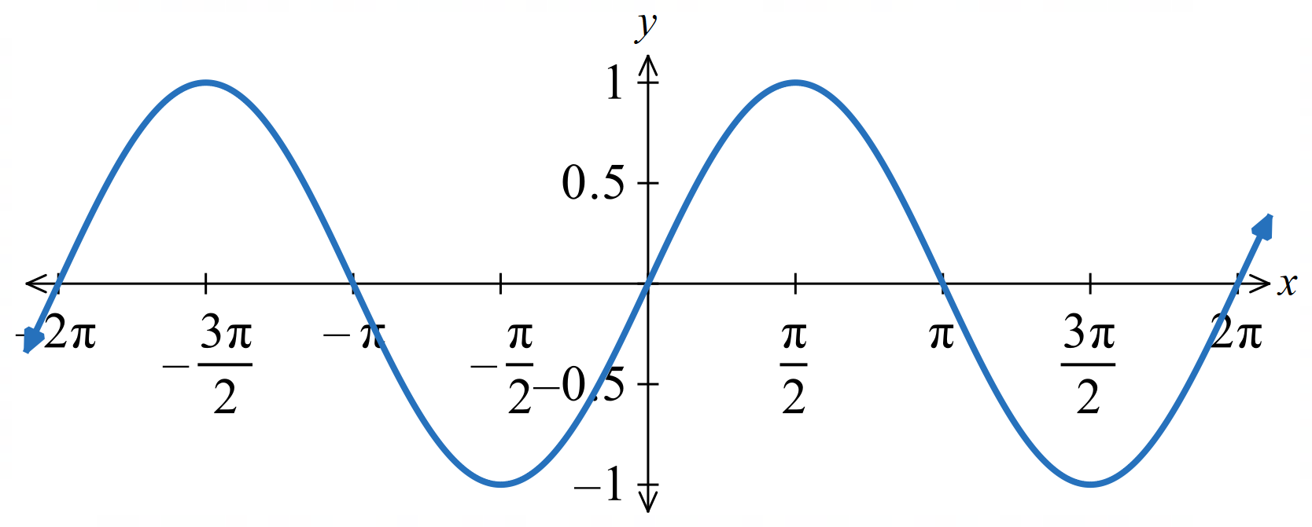

- $\int_{0}^{\frac{π}{4}}{sin x}dx$  $$1-\frac{1}{\sqrt{2}}$$ | - $\int_{0}^{\frac{π}{2}}{sin x}dx$  $$1$$ | - $\int_{0}^{\frac{3π}{4}}{sin x}dx$  $$1+\frac{1}{\sqrt{2}}$$ | - $\int_{0}^{π}{sin x}dx$  $$2$$
- $\int_{0}^{\frac{5π}{4}}{sin x}dx$  $$1+\frac{1}{\sqrt{2}}$$ | - $\int_{0}^{\frac{3π}{2}}{sin x}dx$  $$1$$ | - $\int_{0}^{\frac{7π}{4}}{sin x}dx$  $$1-\frac{1}{\sqrt{2}}$$ | - $\int_{0}^{2π}{sin x}dx$  $$0$$

Development
- Find the following indefinite integrals.
- $\int{cos\left(x + 2\right)}dx$  $$sin\left(x + 2\right)+ C$$ | - $\int{cos\left(2x + 1\right)}dx$  $$\left(\frac{1}{2}\right)sin\left(2x + 1\right)+ C$$ | - $\int{sin\left(x + 2\right)}dx$  $$-cos\left(x + 2\right)+ C$$
- $\int{sin\left(2x + 1\right)}dx$  $$-\left(\frac{1}{2}\right)cos\left(2x + 1\right)+ C$$ | - $\int{cos\left(3x - 2\right)}dx$  $$\left(\frac{1}{3}\right)sin\left(3x - 2\right)+ C$$ | - $\int{sin\left(7 - 5x\right)}dx$  $$\left(\frac{1}{5}\right)cos\left(7 - 5x\right)+ C$$
- $\int{\sec^{2}\left(4 - x\right)}dx$  $$-tan\left(4 - x\right)+ C$$ | - $\int{\sec^{2}\left(\frac{1 - x}{3}\right)}dx$  $$-3 tan\left(\frac{1 - x}{3}\right)+ C$$ | - $\int{sin\left(\frac{1 - x}{3}\right)}dx$  $$3 cos\left(\frac{1 - x}{3}\right)+ C$$

  - Find $\int{\left(6 cos 3x - 4 sin \left(\frac{x}{2}\right)\right)}dx$.

$$2 sin 3x + 8 cos \left(\frac{x}{2}\right)+ C$$
  - Find $\int{\left(8 sec^{2}2x - 10 cos \left(\frac{x}{4}\right)- 36 sin \left(\frac{x}{3}\right)\right)}dx$.

$$4\tan\left(2x\right)+108\cos\left(\frac{x}{3}\right)-40\sin\left(\frac{x}{4}\right)+C$$

  - If $f'(x) = π cos πx$ and $f(0) = 0$, find $f(x)$ and $f\left(\frac{1}{3}\right).$
$$f\left(x\right)= \int{π cos πx}dx = sin πx + C$$
$$f\left(0\right)= 0: sin 0 + C = 0, C = 0$$
$$f\left(x\right)= sin πx$$
$$f\left(\frac{1}{3}\right)= sin\left(\frac{π}{3}\right)=\frac{\sqrt{3}}{2}$$
  - If $f'(x) = cos πx$ and $f\left(0\right)=\frac{1}{2π},$ find $f\left(x\right)$ and f$\left(\frac{1}{6}\right)$.
$$f\left(x\right)= \int{cos πx}dx = \left(\frac{1}{π}\right)sin πx + C$$
$$f\left(0\right)=\frac{1}{2π}: 0 + C =\frac{1}{2π}, C =\frac{1}{2π}$$
$$f\left(x\right)=\frac{1}{2π}+ \left(\frac{1}{π}\right)sin πx$$
$$f\left(\frac{1}{6}\right)=\frac{1}{2π}+ \left(\frac{1}{π}\right)sin\left(\frac{π}{6}\right)=\frac{1}{π}$$

Mastery
- If$f''(x) = 18 cos 3x$ and $f^{'}\left(0\right)= f\left(\frac{π}{2}\right)= 1$, find $f(x).$
$$f^{''}\left(x\right)= 18 cos 3x$$
$$f'(x) = 6 sin 3x + C_{1}$$
$$f^{'}\left(0\right)= 1: 0 + C_{1}= 1, C_{1}= 1$$
$$f'(x) = 6 sin 3x + 1$$
$$f(x) = -2 cos 3x + x + C_{2}$$
$$f\left(\frac{π}{2}\right)= 1: -2 cos\left(\frac{3π}{2}\right)+\frac{π}{2}+ C_{2}= 1$$
$$-2\left(0\right)+\frac{π}{2}+ C_{2}= 1$$
$$C_{2}= 1 -\frac{π}{2}$$
$$f(x) = -2 cos 3x + x + \left(1 -\frac{π}{2}\right)$$

- Find the following indefinite integrals, where $a$, $b$, $u$ and $v$ are constants.
- $\int{a sin\left(ax + b\right)}dx$  $$-cos\left(ax + b\right)+ C$$ | - $\int{π^{2}cos πx}dx$  $$π^{2}\left(\frac{1}{π}\right)sin πx + C = π sin πx + C$$
- $\int{\frac{1}{u}\sec^{2}\left(v + ux\right)}dx$  $$= \left(\frac{1}{u^{2}}\right)tan\left(v + ux\right)+ C$$ | - $\int{\frac{a}{\cos^{2}ax}}$ $dx$  $$tan ax + C$$

  - Using the Pythagorean identity, complete the statement: $1 + tan² x =$ ...……,
$$1+\tan^{2}{x}=\sec^{2}{x}$$
  - Hence find $\int{tan^{2}x}dx$.

$$\int{tan^{2}x}dx = \int{\left(sec^{2}x - 1\right)}dx = tan x - x + C$$
  - Simplify $1 - sin² x$, and hence find the value of $\int_{0}^{\frac{π}{3}}{\frac{2}{1 - sin^{2}x}}$ $dx$.

$$1 - \sin^{2}x = \cos^{2}x$$
$$\frac{2}{1 - \sin^{2}x}=\frac{2}{\cos^{2}x}= 2 \sec^{2}x$$
$$\int_{0}^{\frac{π}{3}}{2 sec^{2}x}dx = {\left[2 tan x\right]}_{0}^{\frac{π}{3}}= 2\sqrt{3}$$

Integrating Exponentials of any Base

- Review
- Differentiate these functions.
- $f\left(x\right)=3^{x}$ | - $f\left(x\right)=5^{2x}$ | - $f\left(x\right)=7^{3x+2}$

- Integrating Exponential Functions of any Base
$$\int{a^{x}}dx=\frac{a^{x}}{\ln{a}}+C$$
$$\int{a^{kx}}dx=\frac{a^{kx}}{k\ln{a}}+C$$

- Integrate reciprocal functions
Find the indefinite integral of the following:
$$\int{3^{x}}dx$$ | $$\int{3^{x+5}}dx$$ | $$\int{3^{2x+5}}dx$$
$$\int{5^{2x+5}}dx$$ | $$\int{5^{5-2x}}dx$$ | $$\int{7^{\frac{x}{3}}}dx$$

Foundation
- Integrate:
- $\int{2^{x}}dx$  $$\frac{2^{x}}{\ln{2}}+ C$$ | - $\int{6^{x}}dx$  $$\frac{6^{x}}{ln 6}+ C$$
- $\int{7^{x}}dx$  $$\frac{7^{x}}{ln 7}+ C$$ | - $\int{3^{x}}dx$  $$\frac{3^{x}}{ln 3}+ C$$

- Integrate:
- $\int_{0}^{1}{2^{x}}dx$  $$1.443$$ | - $\int_{0}^{1}{3^{x}}dx$  $$1.820$$
- $\int_{-1}^{1}{5^{x}}dx$  $$2.982$$ | - $\int_{0}^{2}{4^{x}}dx$  $$10.82$$

- Give the exact value of each integral, then evaluate it correct to four decimal places.
- $\int_{1}^{3}{2^{x}}dx$  $$\frac{6}{ln 2}≑ 8.6562$$ | - $\int_{-1}^{1}{\left(3^{x}+ 1\right)}dx$  $$2 +\frac{8}{3 ln 3}≑ 4.4273$$ | - $\int_{0}^{2}{\left({10}^{x}- 10x\right)}dx$  $$\frac{99}{ln 10}- 20 ≑ 32.9952$$

Mixed Practice

Foundation
- Work out the following:
- $\int{cos x }dx$  $$sin x + C$$ | - $\int{sin x }dx$  $$-cos x + C$$ | - $\int{sec^{2}x }dx$  $$tan x + C$$
- $\int{\frac{dx}{x^{3}}}$  $$-\frac{1}{2x^{2}}+ C$$ | - $\int{\frac{dx}{x^{8}}}$  $$-\frac{1}{7x^{7}}+ C$$ | - $\int{\frac{3}{x^{2}}}$ $dx$  $$-\frac{3}{x}+ C$$
- $\int{\frac{2}{x^{5}}}$ $dx$  $$-\frac{1}{2x^{4}}+ C$$ | - $\int{\sqrt{x}}dx$  $$2\frac{\sqrt{x^{3}}}{3}+ C$$ | - $\int{x^{\frac{1}{3}}}dx$  $$\frac{3x^{\frac{4}{3}}}{4}+ C$$
- $\int{\sqrt[3]{x}}dx$  $$3\frac{\sqrt[3]{x^{4}}}{4} + C$$ | - $\int{x\sqrt{x}}dx$  $$2\frac{\sqrt{x^{5}}}{5}+ C$$ | - $\int{e^{4x}}dx$  $$\left(\frac{1}{4}\right)e^{4x}+ C$$
- $\int{e^{-x}}dx$  $$-e^{-x}+ C$$ | - $\int{e^{5x}}dx$  $$\left(\frac{1}{5}\right)e^{5x}+ C$$ | - $\int{e^{-2x}}dx$  $$\left(-\frac{1}{2}\right)e^{-2x}+ C$$
- $\int{sin 3x }dx$  $$\left(-\frac{1}{3}\right)cos 3x + C$$ | - $\int{-sin 7x }dx$  $$\left(\frac{1}{7}\right)cos 7x + C$$ | - $\int{sec^{2}5x }dx$  $$\left(\frac{1}{5}\right)tan 5x + C$$
- $\int{\frac{2}{x}}$ $dx$  $$2 ln \left|x\right|+ C$$ | - $\int{\frac{5}{3x}}$ $dx$  $$\left(\frac{5}{3}\right)ln \left|x\right|+ C$$ | - $\int{\frac{1}{2x}}$ $dx$  $$\left(\frac{1}{2}\right)ln \left|x\right|+ C$$
- $\int{\left(x - 2\right)\left(x + 5\right)}dx$  $$\frac{x^{3}}{3}+\frac{3x^{2}}{2}- 10x + C$$ | - $\int{{\left(1 - 2x\right)}^{2}}dx$  $$x - 2x^{2}+\frac{4x^{3}}{3}+ C$$ | - $\int{\left(x^{2}- x^{-7}+ 5\right)}dx$  $$\frac{x^{3}}{3}+\frac{x^{-6}}{6}+ 5x + C$$
- $\int{\sqrt{x}\left(1 +\frac{1}{\sqrt{x}}\right)}dx$  $$2\frac{\sqrt{x^{3}}}{3}+ x + C$$ | - $\int{{\left(x + 1\right)}^{4}}dx$  $$\frac{{\left(x + 1\right)}^{5}}{5}+ C$$ | - $\int{{\left(3x - 4\right)}^{2}}dx$  $$\frac{{\left(3x - 4\right)}^{3}}{9}+ C$$

Development
- Work out the following:
- $\int{{\left(1 - x\right)}^{6}}dx$  $$-\frac{{\left(1 - x\right)}^{7}}{7}+ C$$ | - $\int{{\left(5x - 1\right)}^{9}}dx$  $$\frac{{\left(5x - 1\right)}^{10}}{50}+ C$$ | - $\int{{\left(3y - 2\right)}^{7}}dy$  $$\frac{{\left(3y - 2\right)}^{8}}{24}+ C$$
- $\int{cos \left(x + 1\right)}dx$  $$sin \left(x + 1\right)+ C$$ | - $\int{sin \left(2x - 3\right)}dx$  $$\left(-\frac{1}{2}\right)cos \left(2x - 3\right)+ C$$ | - $\int{cos \left(2x - 1\right)}dx$  $$\left(\frac{1}{2}\right)sin \left(2x - 1\right)+ C$$
- $\int{e^{4x+1}}dx$  $$\left(\frac{1}{4}\right)e^{4x+1}+ C$$ | - $\int{-3e^{5x}}dx$  $$\left(-\frac{3}{5}\right)e^{5x}+ C$$ | - $\int{\left(e^{7x}- 2\right)}dx$  $$\left(\frac{1}{7}\right)e^{7x}- 2x + C$$
- $\int{\left(e^{x-3}+ x\right)}dx$  $$e^{x-3}+\frac{x^{2}}{2}+ C$$ | - $\int{sin \left(π - x\right)}dx$  $$-cos x + C$$ | - $\int{cos \left(x + π\right)}dx$  $$-sin x + C$$
- $\int{2 sec^{2}7x }dx$  $$\left(\frac{2}{7}\right)tan 7x + C$$ | - $\int{4 sin \left(\frac{x}{2}\right)}dx$  $$-8 cos \left(\frac{x}{2}\right)+ C$$ | - $\int{3 sec^{2}\left(\frac{x}{3}\right)}dx$  $$9 tan \left(\frac{x}{3}\right)+ C$$
- $\int{\frac{sin x°}{4}}$ $dx$  $$-\left(\frac{45}{π}\right)cos x° + C$$ | - $\int{{\left(4 + 3x\right)}^{4}}dx$  $$\frac{{\left(4 + 3x\right)}^{5}}{15}+ C$$ | - $\int{{\left(7x + 8\right)}^{12}}dx$  $$\frac{{\left(7x + 8\right)}^{13}}{91}+ C$$
- $\int{\sqrt{2x - 5}}dx$  $$\frac{\sqrt{{\left(2x - 5\right)}^{3}}}{3}+ C$$ | - $\int{\frac{2}{2x + 5}}$ $dx$  $$ln \left|2x + 5\right|+ C$$ | - $\int{\frac{4}{2x+ 1}}$ $dx$  $$2\ln\left|2x+1\right|+C$$
- $\int{\frac{x^{6}- 3x^{5}+ 2x^{4}}{x^{3}}}$ $dx$  $$\frac{x^{4}}{4}- x^{3}+ x^{2}+ C$$ | - $\int{\left(x^{2}- 4\right)\left(4x - 1\right)}dx$  $$x^{4}-\frac{x^{3}}{3}- 8x^{2}+ 4x + C$$ | - $\int{\frac{4x^{3}- x^{5}- 3x^{2}+ 7}{x^{5}}}$ $dx$  $$-\frac{4}{x}+ \left(\frac{3}{2x^{2}}\right)- \left(\frac{7}{4x^{4}}\right)- x + C$$
- Work out the following:
- $\int{\frac{4}{4x - 1}}$ $dx$  $$ln \left|4x - 1\right|+ C$$ | - $\int{\frac{1}{x + 3}}$ $dx$  $$ln \left|x + 3\right|+ C$$ | - $\int{e^{2x}}dx$  $$\left(\frac{1}{2}\right)e^{2t}+ C$$
- $\int{3{\left(x + 7\right)}^{-2}}dx$  $$-3{\left(x + 7\right)}^{-1}+ C$$ | - $\int{\sqrt[3]{4x + }}dx$  $$\frac{3\sqrt[3]{{\left(4x+3\right)}^{4}}}{16} + C$$ | - $\int{\sqrt{{\left(t + 3\right)}^{3}}}dt$  $$2\frac{\sqrt{{\left(t + 3\right)}^{5}}}{5}+ C$$
- $\int{\sqrt{{\left(5x + 2\right)}^{5}}}dx$  $$2\frac{\sqrt{{\left(5x + 2\right)}^{7}}}{35}+ C$$ | - $2\int{{\left(3x + 1\right)}^{-4}}dx$  $$-\frac{2{\left(3x + 1\right)}^{-3}}{9}+ C$$ | - $\int{\frac{1}{2{\left(4x - 5\right)}^{3}}}$ $dx$  $$-\frac{1}{16{\left(4x - 5\right)}^{2}}+ C$$
- $\int{{\left(2 - x\right)}^{-\frac{1}{2}}}dx$  $$-2{\left(2 - x\right)}^{\frac{1}{2}}+ C$$ | - $\int{5ˣ }dx$  $$\frac{5ˣ}{ln5} + C$$ | - $\int{7^{3x}}dx$  $$\frac{7^{3x}}{3 ln 7}+ C$$
- $\int{3^{2x-1}}dx$  $$\frac{3^{2x-1}}{2 ln 3}+ C$$ | - $\int_{0}^{\frac{π}{2}}{cos x }dx$  $$1$$ | - $\int_{0}^{1}{e^{5x}}dx$  $$\left(\frac{1}{5}\right)\left(e^{5}- 1\right)$$
- $\int_{1}^{2}{{\left(2x + 1\right)}^{4}}dx$  $$\frac{1441}{5}$$ | - $\int_{0}^{1}{{\left(3y - 2\right)}^{3}}dy$  $$-\frac{5}{4}$$ | - $\int_{1}^{2}{{\left(1 - x\right)}^{7}}dx$  $$-\frac{1}{8}$$
- $\int_{\frac{π}{6}}^{\frac{π}{3}}{sec^{2}x }dx$  $$2\frac{\sqrt{3}}{3}$$ | - $\int_{0}^{\frac{π}{2}}{cos 3x }dx$  $$-\frac{1}{3}$$ | - $\int_{0}^{2}{-e^{-x}}dx$  $$\frac{1}{e^{2}}- 1$$
- Work out the following:
- $\int_{0}^{2}{{\left(3 - 2x\right)}^{5}}dx$  $$\frac{182}{3}$$ | - $\int_{0}^{1}{\frac{{\left(3x - 1\right)}^{2}}{6}}$ $dx$  $$\frac{1}{6}$$ | - $\int_{4}^{5}{{\left(5 - x\right)}^{6}}dx$  $$\frac{1}{7}$$
- $\int_{3}^{6}{\sqrt{x - 2}}dx$  $$\frac{14}{3}$$ | - $\int_{0}^{\frac{1}{2}}{sin \left(πx\right)}dx$  $$\frac{1}{π}$$ | - $\int_{0}^{\frac{π}{8}}{sec^{2}2x }dx$  $$\frac{1}{2}$$
- $\int_{\frac{π}{2}}^{π}{sin \left(\frac{x}{2}\right)}dx$  $$\sqrt{2}$$ | - $\int_{0}^{\frac{π}{12}}{3 cos 2x }dx$  $$\frac{3}{4}$$ | - $\int_{0}^{\frac{π}{10}}{-sin \left(5x\right)}dx$  $$-\frac{1}{5}$$
- $\int_{1}^{4}{2e^{3x+4}}dx$  $$\left(\frac{2e^{7}}{3}\right)\left(e^{9}- 1\right)$$ | - $\int_{0}^{2}{\left(e^{2x}+ 1\right)}dx$  $$\left(\frac{1}{2}\right)e^{4}+\frac{3}{2}$$ | - $\int_{1}^{2}{\left(eˣ - x\right)}dx$  $$e^{2}- e -\frac{3}{2}$$
- $\int_{2}^{3}{\left(3x^{2}- e^{2x}\right)}dx$  $$19 - \left(\frac{1}{2}\right)e^{4}\left(e^{2}- 1\right)$$ | - $\int_{0}^{3}{\left(e^{2x}- e^{-x}\right)}dx$  $$\left(\frac{1}{2}\right)e^{6}+ e^{-3}-\frac{3}{2}$$ | - $\int_{0}^{2}{\frac{5}{{\left(2x + 1\right)}^{3}}}$ $dx$  $$\frac{6}{5}$$
- $\int_{1}^{4}{\frac{2}{\sqrt{{\left(5x - 4\right)}^{3}}}}$ $dx$  $$\frac{3}{5}$$ | - $\int_{1}^{3}{\frac{2}{2x + 5}}$ $dx$  $$0.5$$ | - $\int_{2}^{5}{\frac{1}{x + 1}}$ $dx$  $$0.7$$
- $\int{\left(cos x cos \left(\frac{π}{3}\right)- sin x sin \left(\frac{π}{3}\right)\right)}dx$  $$\frac{\sin{x}+\sqrt{3}\cos{x}}{2}+C$$ | - $\int{\left(sin π cos x - cos π sin x\right)}dx$  $$-\cos{x}+C$$

  - Show that $\frac{3x + 3}{x^{2}- 9}=\frac{1}{x + 3}+\frac{2}{x - 3}$

$$RHS =\frac{1}{x + 3}+\frac{2}{x - 3}$$
$$=\frac{\left(x - 3\right)+ 2\left(x + 3\right)}{\left(x + 3\right)\left(x - 3\right)}$$
$$=\frac{3x + 3}{x^{2}- 9}= LHS$$
  - Hence find $\int{\frac{3x + 3}{x^{2}- 9}}$ $dx$.

$$ln |x + 3| + 2 ln |x - 3| + C$$

  - Show that $\frac{x - 6}{x - 1}= 1 -\frac{5}{x - 1}$.

$$RHS = 1 -\frac{5}{x - 1}$$
$$=\frac{\left(x - 1\right)- 5}{x - 1}$$
$$=\frac{x - 6}{x - 1}= LHS$$
  - Hence find $\int{\frac{x - 6}{x - 1}}$ $dx$.

$$x - 5 ln |x - 1| + C$$

Reverse Chain Rule for Power Functions

- Investigation Standard integral for power functions
- Differentiate ${\left(x^{3}+5\right)}^{8}$ using the chain rule. |  |  | - Therefore, find:  $$\int{24x^{2}{\left(x^{3}+5\right)}^{7}}dx$$ |  |  |  | - and find:  $$\int{x^{2}{\left(x^{3}+5\right)}^{7}}dx$$  $$=\frac{1}{24}\int{24x^{2}{\left(x^{3}+5\right)}^{7}}dx$$
- Differentiate $\frac{1}{x^{2}+1}$ using the chain rule. |  |  | - Therefore, find:  $$\int{-\frac{2x}{{\left(1+x^{2}\right)}^{2}}}dx$$ |  |  |  | - and find:  $$\int{\frac{x}{{\left(1+x^{2}\right)}^{2}}}dx$$
Reversing the chain rule requires you to identify the inner function and its derivative in the integrand.
You can adjust for a missing constant. Constants multiply every output by the same amount, so you can pull it outside the integral and recover the original function.
✔
$$\int{x^{2}{\left(x^{3}+5\right)}^{7}}dx$$
$$=\frac{1}{24}\int{24x^{2}{\left(x^{3}+5\right)}^{3}}dx$$

You cannot adjust for a missing variable term. Variables change value depending on $x$,
it does not scale every output equally and cannot be separated from the integral.

$$\int{{\left(x^{3}+5\right)}^{7}}dx$$
$$=\frac{1}{24x^{2}}\int{24x^{2}{\left(x^{3}+5\right)}^{7}}dx$$

So, you cannot use reverse chain rule to integrate ${\left(x^{3}+ 5\right)}^{7}$ because the integrand does not contain the derivative of the inner function, $3x²$. The only way to integrate this expression is to expand it into individual terms.

Constants can move freely across an integral sign; variables cannot.
- Identify whether you can integrate using reverse chain rule for power functions
We can integrate expressions of the form $f^{'}\left(x\right)\left[f\left(x\right)\right]ⁿ,$ or any constant multiple of $f^{'}\left(x\right).$
This works because constants can be factored out of an integral, but variable terms cannot.
✖  $$\int{{\left(x^{2}+5\right)}^{4}}dx$$ | ✔  $$\int{{2x\left(x^{2}+5\right)}^{4}}dx$$ |  |  | ✔  $$\int{{x\left(x^{2}+5\right)}^{4}}dx$$ |  | ✔  $$\int{{-7x\left(x^{2}+5\right)}^{4}}dx$$ |  |  | ✖  $$\int{{x^{3}\left(x^{2}+5\right)}^{4}}dx$$
Identify whether you can integrate the following:
$$\int{4x{\left(2x^{2}+ 3\right)}^{5}}dx$$ |  | $$\int{x^{2}{\left(2x^{2}+ 3\right)}^{5}}dx$$ |  |  | $$\int{x^{4}{\left(x^{5}+ 1\right)}^{3}dx}$$ |  |  | $$\int{6x{\left(3x^{2}- 4\right)}^{7}}dx$$
$$\int{x^{3}{\left(x^{5}+ 1\right)}^{3}}dx$$ |  | $$\int{2x^{2}{\left(x^{3}+ 2\right)}^{4}}dx$$ |  |  | $$\int{{\left(3x^{2}- 4\right)}^{7}x}dx$$ |  |  | $$\int{x^{2}{\left(1+x^{5}\right)}^{3}}dx$$

- Identify the adjustment factor for reverse chain rule of power functions
These expressions are of the form $f^{'}\left(x\right)\left[f\left(x\right)\right]ⁿ.$ Adjust the following for integrating:
$$\int{x{\left(x^{2}+ 3\right)}^{5}dx}$$  $$=\frac{1}{2}\int{2x{\left(x^{2}+3\right)}^{5}}dx$$ |  | $$\int{x{\left(3x^{2}+ 1\right)}^{4}}dx$$  $$=\frac{1}{6}\int{6x{\left(3x^{2}+1\right)}^{4}}dx$$ |  | $$\int{2x^{2}{\left(x^{3}- 5\right)}^{4}}dx$$  $$=\frac{2}{3}\int{3x^{2}{\left(x^{3}- 5\right)}^{4}}dx$$
$$\int{x^{3}{\left(x^{4}+ 1\right)}^{6}}dx$$ | $$\int{x{\left(2x^{2}+ 3\right)}^{5}}dx$$ |  | $$\int{x^{3}{\left(x^{4}+ 1\right)}^{600}}dx$$ |  | $$\int{2x^{3}{\left(x^{4}+ 1\right)}^{600}}dx$$
$$\int{x{\left(5x^{2}- 3\right)}^{3}}dx$$ | $$\int{4x{\left(5x^{2}- 3\right)}^{3}}dx$$ |  | $$\int{4x^{2}{\left(x^{3}+ 7\right)}^{8}}dx$$ |  | $$\int{x^{2}{\left(4x^{3}+ 7\right)}^{8}}dx$$

- Reverse Chain Rule for Power Functions
Reverse chain rule requires the derivative of the inner function in the integrand.

$$\int{f^{'}\left(x\right){\left[f\left(x\right)\right]}^{n}}dx=\frac{{\left[f\left(x\right)\right]}^{n+1}}{n+1}+C$$
            - Identify the inner function $f\left(x\right)$.
            - Check whether the expression contains $f'\left(x\right).$
If it does not, you cannot use this rule.
            - Adjust for any missing constant factors.
            - Write the result as $\frac{{\left[f\left(x\right)\right]}^{n+1}}{n+1}$ $+C$

- Example Integrate using the reverse chain rule for power functions
$$\int{x{\left(x^{2}+1\right)}^{3}}dx$$  1. Inner function is $f\left(x\right)=x^{2}+1$  2. We need $f^{'}\left(x\right)=2x$  3.  $$=\frac{1}{2}\int{2x{\left(x^{2}+1\right)}^{3}}dx$$  4.  $$=\frac{1}{2}\frac{{\left(x^{2}+1\right)}^{4}}{4}+C$$  $$=\frac{1}{8}{\left(x^{2}+1\right)}^{4}+C$$ | $$\int{x^{2}\sqrt{x^{3}-1}}dx$$  1. Inner function is $f\left(x\right)=x^{3}-1$  2. We need $f^{'}\left(x\right)=3x^{2}$  3.  $$=\frac{1}{3}\int{3x^{2}{\left(x^{3}-1\right)}^{\frac{1}{2}}}dx$$  4.  $$=\frac{1}{3}\frac{{\left(x^{3}-1\right)}^{\frac{3}{2}}}{\left(\frac{2}{3}\right)}+C$$  $$=\frac{2}{9}\sqrt{{\left(x^{3}-1\right)}^{3}}+C$$

- Guided Practice
$$\int{x^{2}{\left(x^{3}+5\right)}^{3}}dx$$  $$\frac{1}{12}{\left(x^{3}+5\right)}^{4}+C$$ | $$\int{x\sqrt{1-x^{2}}}dx$$  $$-\frac{1}{3}\sqrt{{\left(1-x^{2}\right)}^{3}}+C$$

Foundation

- Find $\frac{d}{dx}{\left(x^{2}+ 3\right)}^{4}$  $$8x(x² + 3)³$$ | - $\int{8x{\left(x^{2}+ 3\right)}^{3}}dx$  $${\left(x^{2}+ 3\right)}^{4}+ C$$ | - $\int{40x{\left(x^{2}+ 3\right)}^{3}}dx$  $$5{\left(x^{2}+ 3\right)}^{4}+ C$$

- Find $\frac{d}{dx}{\left(x^{3}- 1\right)}^{5}$  $$15x^{2}{\left(x^{3}- 1\right)}^{4}$$ | - $\int{15x^{2}{\left(x^{3}- 1\right)}^{4}}dx$  $${\left(x^{3}- 1\right)}^{5}+ C$$ | - $\int{3x^{2}{\left(x^{3}- 1\right)}^{4}}dx$  $$\frac{{\left(x^{3}- 1\right)}^{5}}{5}+ C$$

- Find $\frac{d}{dx}\sqrt{2x^{2}+ 3}$  $$\frac{2x}{\sqrt{2x^{2}+ 3}}$$ | - $\int{\frac{2x}{\sqrt{2x^{2}+ 3}}}$ $dx$  $$\sqrt{2x^{2}+ 3}+ C$$ | - $\int{\frac{x}{\sqrt{2x^{2}+ 3}}}$ $dx$  $$\frac{1}{2}\sqrt{2x^{2}+ 3}+ C$$

- Find $\frac{d}{dx}{\left(\sqrt{x}+ 1\right)}^{3}$  $$\frac{3{\left(\sqrt{x}+ 1\right)}^{2}}{2\sqrt{x}}$$ | - $\int{\frac{3{\left(\sqrt{x}+ 1\right)}^{2}}{2\sqrt{x}}}$ $dx$  $${\left(\sqrt{x}+ 1\right)}^{3}+ C$$ | - $\int{\frac{{\left(\sqrt{x}+ 1\right)}^{2}}{\sqrt{x}}}$ $dx$  $$\frac{2}{3}{\left(\sqrt{x}+ 1\right)}^{3}+ C$$

  - Find $\frac{d}{dx}{\left(x^{3}+ 3x^{2}+ 5\right)}^{4}$

12(x² + 2x)(x³ + 3x² + 5)³
  - $\int{12\left(x^{2}+ 2x\right){\left(x^{3}+ 3x^{2}+ 5\right)}^{3}}dx$

(x³ + 3x² + 5)⁴ + C
  - $\int{\left(x^{2}+ 2x\right){\left(x^{3}+ 3x^{2}+ 5\right)}^{3}}dx$

1/12 (x³ + 3x² + 5)⁴ + C

Development

  - Find $\frac{d}{dx}{\left(5 - x^{2}- x\right)}^{7}$

$$-7\left(2x + 1\right){\left(5 - x^{2}- x\right)}^{6}$$
  - $\int{\left(-14x - 7\right){\left(5 - x^{2}- x\right)}^{6}}dx$

$$(5 - x² - x)⁷ + C$$
  - $\int{\left(2x + 1\right){\left(5 - x^{2}- x\right)}^{6}}dx$

$$-\frac{1}{7}{\left(5 - x^{2}- x\right)}^{7}+ C$$
- Integrate:
- $\int{5{\left(5x + 4\right)}^{3}}dx$  $$\frac{1}{4}{\left(5x + 4\right)}^{4}+ C$$ | - $\int{-3{\left(1 - 3x\right)}^{5}}dx$  $$\frac{1}{6}{\left(1 - 3x\right)}^{6}+ C$$ | - $\int{2x{\left(x^{2}- 5\right)}^{7}}dx$  $$\frac{1}{8}{\left(x^{2}- 5\right)}^{8}+ C$$
- $\int{3x^{2}{\left(x^{3}+ 7\right)}^{4}}dx$  $$\frac{1}{5}{\left(x^{3}+ 7\right)}^{5}+ C$$ | - $\int{\frac{6x}{{\left(3x^{2}+ 2\right)}^{2}}}$ $dx$  $$-\frac{1}{3x^{2}+ 2}+ C$$ | - $\int{-\frac{6x^{2}}{\sqrt{9 - 2x^{3}}}}$ $dx$  $$2\sqrt{9 - 2x^{3}}+ C$$

- Integrate:
- $\int{10x{\left(5x^{2}+ 3\right)}^{2}}dx$  $$\frac{1}{3}{\left(5x^{2}+ 3\right)}^{3}+ C$$ | - $\int{2x{\left(x^{2}+ 1\right)}^{3}}dx$  $$\frac{1}{4}{\left(x^{2}+ 1\right)}^{4}+ C$$ | - $\int{12x^{2}{\left(1 + 4x^{3}\right)}^{5}}dx$  $$\frac{1}{6}{\left(1 + 4x^{3}\right)}^{6}+ C$$
- $\int{x{\left(1 + 3x^{2}\right)}^{4}}dx$  $$\frac{1}{30}{\left(1 + 3x^{2}\right)}^{5}+ C$$ | - $\int{x^{3}{\left(1 - x^{4}\right)}^{7}}dx$  $$-\frac{1}{32}{\left(1 - x^{4}\right)}^{8}+ C$$ | - $\int{3x^{2}\sqrt{x^{3}- 1}}dx$  $$\frac{2}{3}{\left(x^{3}- 1\right)}^{\frac{3}{2}}+ C$$
- $\int{x\sqrt{5x^{2}+ 1}}dx$  $$\frac{1}{15}{\left(5x^{2}+ 1\right)}^{\frac{3}{2}}+ C$$ | - $\int{\frac{2x}{\sqrt{x^{2}+ 3}}}$ $dx$  $$2\sqrt{x^{2}+ 3}+ C$$ | - $\int{\frac{x + 1}{\sqrt{4x^{2}+ 8x + 1}}}$ $dx$  $$\frac{1}{4}\sqrt{4x^{2}+ 8x + 1}+ C$$
- Evaluate:
- $\int_{-1}^{1}{x^{2}{\left(x^{3}+ 1\right)}^{4}}dx$  $$\frac{32}{15}$$ | - $\int_{0}^{1}{\frac{x}{{\left(5x^{2}+ 1\right)}^{3}}}$ $dx$  $$\frac{7}{144}$$
- $\int_{0}^{\frac{1}{2}}{x\sqrt{1 - 4x^{2}}}dx$  $$\frac{1}{12}$$ | - $\int_{-3}^{-1}{\left(x + 5\right){\left(x^{2}+ 10x + 3\right)}^{2}}dx$  $$936$$

Further Reverse Chain Rule

- Review
- Differentiate exponential functions using chain rule
- $\frac{d}{dx}$ $\left(e^{x^{2}+3}\right)$ | - $\frac{d}{dx}$ $\left(e^{2-5x+x^{3}}\right)$ | - $\frac{d}{dx}$ $\left({\left(1-e^{3x}\right)}^{3}\right)$

- Differentiate logarithmic functions using chain rule
- $\frac{d}{dx}$ $\left(\ln\left(x^{2}+5\right)\right)$ | - $\frac{d}{dx}$ $\left(3\ln\left(9-x^{3}\right)\right)$ | - $\frac{d}{dx}$ $\left(\ln\left(e^{x}\right)\right)$

- Differentiate trigonometric functions using chain rule
- $\frac{d}{dx}\left(\sin\left(7x^{2}\right)\right)$ | - $\frac{d}{dx}\left(\cos\left(\frac{x^{2}}{5}\right)\right)$ | - $\frac{d}{dx}\left(\tan\left(4x^{2}-3\right)\right)$

- Reverse Chain Rule for Exponential Functions of Base $e$
$$\int{f^{'}\left(x\right)e^{f\left(x\right)}}dx=e^{f\left(x\right)}+C$$

            - Identify the inner function $f\left(x\right)$ — the exponent of base $e$.
            - Check whether the expression contains $f'(x).$
If it does not, you cannot use this rule.
- Adjust for any missing constant factors.
- Write the result as $e^{f\left(x\right)}+C$

- Example Integrate exponential functions using reverse chain rule
$$\int{xe^{x^{2}+5}}dx$$  1. Inner function is $x^{2}+5$  2. We need $2x$  3.  $$=\frac{1}{2}\int{2xe^{x^{2}+5}}dx$$  4.  $$=\frac{1}{2}e^{x^{2}+5}+C$$ | $$\int{\frac{e^{2x}}{{\left(1-e^{2x}\right)}^{4}}} dx$$  1. Inner function is $1-e^{2x}$  2. We need $-2e^{2x}$  3.  $$=-\frac{1}{2}\int{-2e^{2x}{\left(1-e^{2x}\right)}^{-4}}dx$$  4.  $$=-\frac{1}{2}\frac{{\left(1-e^{2x}\right)}^{-3}}{-3}+C$$  $$=\frac{1}{6{\left(1-e^{2x}\right)}^{3}}+C$$

- Guided Practice
$$\int{x^{2}e^{x^{3}+1}}dx$$  $$\frac{e^{x^{3}+1}}{3}+C$$ | $$\int{\frac{e^{3x}}{{\left(2+e^{3x}\right)}^{5}}}dx$$  $$-\frac{1}{12{\left(e^{3x}+2\right)}^{4}}+C$$
$$\int{\frac{e^{2x}}{{\left(3+e^{2x}\right)}^{3}}}dx$$  $$-\frac{1}{4{\left(e^{2x}+3\right)}^{2}}+C$$ | $$\int{xe^{1-x^{2}}}dx$$  $$-\frac{e^{1-x^{2}}}{2}+C$$
- Reverse Chain Rule for Reciprocal Functions
$$\int{\frac{f^{'}\left(x\right)}{f\left(x\right)}}dx=\ln\left|f\left(x\right)\right|+C$$

            - Identify the function $f\left(x\right)$ — the function with power 1 in the denominator.
            - Check whether the numerator contains $f'(x).$
If it does not, you cannot use this rule.
            - Adjust for any missing constant factors.
            - Write the result as $ln|f(x)| + C$.

- Example Integrate reciprocal functions using reverse chain rule
$$\int{\frac{2x}{x^{2}+2}}dx$$  1. Inner function is $x^{2}+2$  2. We need $2x$  3. no adjustment needed  4.  $$=\ln\left|x^{2}+2\right|+C$$ | $$\int{\frac{x}{9-x^{2}}} dx$$  1. Inner function is $9-x^{2}$  2. We need $-2x$  3.  $$=-\frac{1}{2}\int{\frac{-2x}{9-x^{2}}} dx$$  4.  $$=-\frac{1}{2}\ln\left|9-x^{2}\right|+C$$

- Guided Practice
$$\int{\frac{3x^{2}}{x^{3}+5}}dx$$  $$\ln\left|x^{3}+5\right|+C$$ | $$\int{\frac{6x}{3x^{2}+1}}dx$$  $$\ln\left|3x^{2}+1\right|+C$$
$$\int{\frac{x}{4-x^{2}}}dx$$  $$-\frac{\ln\left|4-x^{2}\right|}{2}+C$$ | $$\int{\frac{x}{5x^{2}-4}}dx$$  $$\frac{\ln\left|5x^{2}-4\right|}{10}+C$$
- Reverse Chain Rule for Trigonometric Functions
$$\int{f^{'}\left(x\right)\sin{f\left(x\right)}}dx=-\cos{f\left(x\right)}+C \\ \int{f^{'}\left(x\right)\cos{f\left(x\right)}}dx=\sin{f\left(x\right)}+C \\ \int{f^{'}\left(x\right)\sec^{2}{f\left(x\right)}}dx=\tan{f\left(x\right)}+C$$

- Example Integrate trigonometric functions using reverse chain rule
$$\int{x\sin\left(x^{2}\right)}dx$$  1. Inner function is $x^{2}$  2. We need $2x$  3.  $$=\frac{1}{2}\int{2x\sin\left(x^{2}\right)}dx$$  4.  $$=-\frac{1}{2}\cos\left(x^{2}\right)+C$$ | $$\int{x^{2}\sec^{2}\left(5x^{3}+2\right)}dx$$  1. Inner function is $5x^{3}+2$  2. We need $15x^{2}$  3.  $$=\frac{1}{15}\int{15x^{2}\sec^{2}\left(5x^{3}+2\right)}dx$$  4.  $$=\frac{1}{15}\tan\left(5x^{3}+2\right)+C$$

- Guided Practice
$$\int{3x^{2}\cos\left(x^{3}\right)}dx$$  $$\sin\left(x^{3}\right)$$ | $$\int{x^{3}\sec^{2}\left(x^{4}-1\right)}dx$$  $$\frac{\tan{(x^{4}}-1) }{4}+C$$
$$\int{x^{3}\sin\left(x^{4}-1\right)}dx$$  $$-\frac{\cos\left(x^{4}-1\right)}{4}+C$$ | $$\int{\sin{x}\cos^{2}{x}}dx$$  $$-\frac{\cos^{3}{x}}{3}+C$$

Foundation

- Differentiate $e^{x^{2}+ 3}.$  $$2xe^{x^{2}+ 3}$$ | - Hence find $\int{2xe^{x^{2}+ 3}}dx.$  $$e^{x^{2}+ 3}+ C$$

- Differentiate $e^{x^{2}- 2x + 3}.$  $$2\left(x - 1\right)e^{x^{2}- 2x + 3}$$ | - Hence find $\int{\left(x - 1\right)e^{x^{2}- 2x + 3}}dx.$  $$\frac{1}{2}e^{x^{2}- 2x + 3}+ C$$

- Differentiate $e^{3x^{2}+ 4x + 1}.$  $$\left(6x + 4\right)e^{3x^{2}+ 4x + 1}$$ | - Hence find $\int{\left(3x + 2\right)e^{3x^{2}+ 4x + 1}}dx.$  $$\frac{1}{2}e^{3x^{2}+ 4x + 1}+ C$$

- Differentiate $y = e^{x^{3}}.$  $$3x^{2}e^{x^{3}}$$ | - Hence find $\int_{-1}^{0}{x^{2}e^{x^{3}}}dx.$  $$\frac{1}{3}\left(1 - e^{-1}\right)$$

- Find the primitive:
- $\frac{2x}{x^{2}- 9}$  $$ln \left|x^{2}- 9\right|+ C$$ | - $\frac{6x + 1}{3x^{2}+ x}$  $$ln \left|3x^{2}+ x\right|+ C$$ | - $\frac{2x + 1}{x^{2}+ x - 3}$  $$ln \left|x^{2}+ x - 3\right|+ C$$
- $\frac{5 - 6x}{2 + 5x - 3x^{2}}$  $$ln \left|2 + 5x - 3x^{2}\right|+ C$$ | - $\frac{x + 3}{x^{2}+ 6x - 1}$  $$\frac{1}{2}ln \left|x^{2}+ 6x - 1\right|+ C$$ | - $\frac{3 - x}{12x - 3 - 2x^{2}}$  $$\frac{1}{4}ln \left|12x - 3 - 2x^{2}\right|+ C$$
- $\frac{e^{x}}{1 + e^{x}}$  $$ln \left(1 + e^{x}\right)+ C$$ | - $\frac{e^{-x}}{1 + e^{-x}}$  $$-ln \left(1 + e^{-x}\right)+ C$$ | - $\frac{e^{x}- e^{-x}}{e^{x}+ e^{-x}}$  $$ln \left(e^{x}+ e^{-x}\right)+ C$$

- Find primitives of:
- $xe^{x^{2}}$  $$\frac{1}{2}e^{x^{2}}+ C$$ | - $4xe^{x^{2}- 7}$  $$2e^{x^{2}- 7}+ C$$ | - $\left(3x + 2\right)e^{3x^{2}+ 4x + 1}$  $$\frac{1}{2}e^{3x^{2}+ 4x + 1}+ C$$
- $\left(x^{2}- 2x\right)e^{x^{3}- 3x^{2}}$  $$\frac{1}{3}e^{x^{3}- 3x^{2}}+ C$$ | - $x^{-2}e^{x^{-1}}$  $$-e^{x^{-1}}+ C$$ | - $-\sqrt{x}e^{-x\sqrt{x}}$  $$\frac{2}{3}e^{-x\sqrt{x}}+ C$$

- Integrate:
- $\int{\frac{3x^{2}}{x^{3}- 5}}$ $dx$  $$\int{\frac{3x^{2}}{x^{3}- 5}}dx = \log_{e}\left|x^{3}- 5\right|+ C$$ | - $\int{\frac{4x^{3}+ 1}{x^{4}+ x - 5}}$ $dx$  $$\int{\frac{4x^{3}+ 1}{x^{4}+ x - 5}}dx = \log_{e}\left|x^{4}+ x - 5\right|+ C$$ | - $\int{\frac{x^{3}- 3x}{x^{4}- 6x^{2}}}$ $dx$  $$\int{\frac{x^{3}- 3x}{x^{4}- 6x^{2}}}dx =\frac{1}{4}\log_{e}\left|x^{4}- 6x^{2}\right|+ C$$
- $\int{\frac{10x^{3}- 7x}{5x^{4}- 7x^{2}+ 8}}$ $dx$  $$\int{\frac{10x^{3}- 7x}{5x^{4}- 7x^{2}+ 8}}dx$$  $$=\frac{1}{2}\log_{e}\left|5x^{4}- 7x^{2}+ 8\right|+ C$$ | - $\int_{2}^{3}{\frac{3x^{2}- 1}{x^{3}- x}}$ $dx$  $$\int_{2}^{3}{\frac{3x^{2}- 1}{x^{3}- x}}dx = {\left[\log_{e}\left|x^{3}- x\right|\right]}_{2}^{3}$$  $$= \log_{e}24 - \log_{e}6$$  $$= \log_{e}4 = 2 \log_{e}2$$ | - $\int_{e}^{2e}{\frac{2x + 2}{x^{2}+ 2x}}$ $dx$  $$\int_{e}^{2e}{\frac{2x + 2}{x^{2}+ 2x}}dx = {\left[log_{e}\left|x^{2}+ 2x\right|\right]}_{e}^{2e}$$  $$= log_{e}\left(4e^{2}+ 4e\right)- log_{e}\left(e^{2}+ 2e\right)$$  $$= log_{e}\left(\frac{4e\left(e + 1\right)}{e\left(e + 2\right)}\right)$$  $$= log_{e}\left(\frac{4\left(e + 1\right)}{e + 2}\right)$$

- Differentiate $e^{sin x},$ and hence find $\int_{0}^{\frac{π}{2}}{cos x e^{sin x}}dx$.

$$\frac{d}{dx}e^{sin x}= cos x e^{sin x}$$
$$\int_{0}^{\frac{π}{2}}{cos x e^{sin x}}dx = {\left[e^{sin x}\right]}_{0}^{\frac{π}{2}}= e - 1$$

Development
- Differentiate $e^{tan x},$ and hence find $\int_{0}^{\frac{π}{4}}{sec^{2}x e^{tan x}}dx.$

$$\frac{d}{dx}e^{tan x}= sec^{2}x e^{tan x}$$
$$\int_{0}^{\frac{π}{4}}{sec^{2}x e^{tan x}}dx = {\left[e^{tan x}\right]}_{0}^{\frac{π}{4}}= e^{1}- e^{0}= e - 1$$

- Find $\frac{d}{dx}\left(sin^{5}x\right)$, and hence find $\int{sin^{4}x cos x}dx$.

$$\frac{d}{dx}\left(sin^{5}x\right)= 5 sin^{4}x cos x$$
$$sin^{4}x cos x =\frac{1}{5}× 5 sin^{4}x cos x$$
$$\int{sin^{4}x cos x}dx =\frac{1}{5}sin^{5}x + C$$
- Find $\frac{d}{dx}\left(tan^{3}x\right)$, and hence find $\int{tan^{2}x sec^{2}x}dx.$

$$\frac{d}{dx}\left(tan^{3}x\right)= 3 tan^{2}x sec^{2}x$$
$$tan^{2}x sec^{2}x =\frac{1}{3}× 3 tan^{2}x sec^{2}x$$
$$\int{tan^{2}x sec^{2}x}dx =\frac{1}{3}tan^{3}x + C$$

  - Show that $f(x) = xe^{-x^{2}}$ is an odd function.

$$f\left(-x\right)= \left(-x\right)e^{-{\left(-x\right)}^{2}}$$
$$= -xe^{-x^{2}}$$
$$= -f\left(x\right)$$
  - Hence evaluate $\int_{-\sqrt{2}}^{\sqrt{2}}{ xe^{-x^{2}}}dx$.

0
- By treating the integrand as a reciprocal function, show that $\int_{0}^{\frac{π}{6}}{\frac{\cos{x}}{1 +\sin{x}}}$ $dx≈0.4.$

$$\int_{0}^{\frac{π}{6}}{\frac{\cos{x}}{1 +\sin{x}}}dx$$
$$f\left(x\right)= 1 + sin x, f^{'}\left(x\right)= cos x$$
$$= {\left[ln \left(1 + sin x\right)\right]}_{0}^{\frac{π}{6}}$$
$$=\ln\left(1 +\frac{1}{2}\right)-\ln{1}$$
$$= ln \left(\frac{3}{2}\right)≈ 0.4$$
- Show that $\int{\frac{e^{x}+ 1}{e^{\frac{1}{2}x}+ e^{-\frac{1}{2}x}}}$ $dx = 2e^{\frac{1}{2}x}+ C.$
Multiply numerator and denominator by $e^{\frac{1}{2}x}:$
$$\frac{e^{x}+ 1}{e^{\frac{1}{2}x}+ e^{-\frac{1}{2}x}}=\frac{e^{\frac{1}{2}x}\left(e^{x}+ 1\right)}{e^{x}+ 1}$$
$$= e^{\frac{1}{2}x}$$
$$\int{e^{\frac{1}{2}x}}dx = 2e^{\frac{1}{2}x}+ C$$

- Use $\tan{x}=$ $\frac{\sin{x}}{\cos{x}}$ to show that $\int_{0}^{\frac{π}{4}}{tan x}dx=\frac{1}{2}ln 2.$

$$\int_{0}^{\frac{π}{4}}{tan x}dx = \int_{0}^{\frac{π}{4}}{\frac{\sin{x}}{\cos{x}}}dx$$
$$= {\left[-ln \left|cos x\right|\right]}_{0}^{\frac{π}{4}}$$
$$= -\ln\left(\frac{1}{\sqrt{2}}\right)+\ln{1}$$
$$=\ln{\sqrt{2}}$$
$$=\frac{1}{2}ln 2$$
- Use $\cot{x}=$ $\frac{\cos{x}}{\sin{x}}$ to find $\int_{\frac{π}{6}}^{\frac{π}{2}}{cot x}dx$.
$$\int_{\frac{π}{6}}^{\frac{π}{2}}{\frac{\cos{x}}{\sin{x}}} dx = {\left[ln \left(sin x\right)\right]}_{\frac{π}{6}}^{\frac{π}{2}}$$
$$= ln 1 - ln \left(\frac{1}{2}\right) = ln 2$$

- Differentiate $(log_{e} x)²,$ and hence find $\int_{\sqrt{e}}^{e}{\frac{log_{e}x}{x} }$ $dx$.

$$\frac{d}{dx}{\left(log_{e}x\right)}^{2}= 2 log_{e}x ×\frac{1}{x}= 2\frac{log_{e}x}{x}$$
$$\frac{log_{e}x}{x}=\frac{1}{2}× 2\frac{log_{e}x}{x}$$
$$\int_{\sqrt{e}}^{e}{\frac{log_{e}x}{x}} dx =\frac{1}{2}{\left[{\left(log_{e}x\right)}^{2}\right]}_{\sqrt{e}}^{e}=\frac{1}{2\left(1 -\frac{1}{4}\right)}=\frac{3}{8}$$

- Differentiate $ln(ln x)$ and hence determine the family of primitives of $\frac{1}{x ln x}.$

$$\frac{d}{dx}ln\left(ln x\right)=\frac{1}{ln x}×\frac{1}{x}=\frac{1}{x ln x}$$
$$\int{\frac{1}{x ln x}}dx = ln\left(ln x\right)+ C$$

Mastery
- Evaluate:
- $\int_{0}^{π}{sin x cos^{8}x}dx$  $$\int_{0}^{π}{sin x \cos^{8}x}dx = {\left[-\frac{\cos^{9}x}{9}\right]}_{0}^{π}$$  $$= -\frac{{\left(-1\right)}^{9}}{9}+\frac{1^{9}}{9}=\frac{2}{9}$$ | - $\int_{0}^{\frac{π}{2}}{sin x cos^{n}x}dx$  $$\int_{0}^{\frac{π}{2}}{sin x \cos^{n}x}dx = {\left[-\frac{\cos^{n+1}x}{n + 1}\right]}_{0}^{\frac{π}{2}}$$  $$= 0 - \left(-\frac{1}{n + 1}\right)=\frac{1}{n + 1}$$
- $\int_{-\frac{π}{2}}^{\frac{π}{2}}{cos x sin^{7}x}dx$  $$\int_{\frac{π}{2}}^{\frac{π}{2}}{\cos{x}\sin^{7}x dx} = \left[\frac{\sin^{8}x}{8}\right]{\left(-\frac{π}{2}\right)}^{\frac{π}{2}}$$  $$=\frac{1}{8}-\frac{{\left(-1\right)}^{8}}{8}$$  $$= 0$$ | - $\int_{0}^{\frac{π}{6}}{cos x sin^{n}x}dx$  $$\int_{0}^{\frac{π}{6}}{cos x \sin^{n}x}dx = {\left[\frac{\sin^{n+1}x}{n + 1}\right]}_{0}^{\frac{π}{6}}$$  $$=\frac{{\left(\frac{1}{2}\right)}^{n+1}}{n + 1}$$  $$=\frac{1}{2^{\left(n+1\right)\left(n + 1\right)}}$$
- $\int_{0}^{\frac{π}{3}}{sec^{2}x tan^{7}x}dx$  $$\int_{0}^{\frac{π}{3}}{\sec^{2}x \tan^{7}x}dx = {\left[\frac{\tan^{8}x}{8}\right]}_{0}^{\frac{π}{3}}$$  $$=\frac{{\left(\sqrt{3}\right)}^{8}}{8}$$  $$= 10\frac{1}{8}$$ | - $\int_{0}^{\frac{π}{4}}{sec^{2}x tan^{n}x}dx$  $$\int_{0}^{\frac{π}{4}}{\sec^{2}x \tan^{n}x}dx = {\left[\frac{\tan^{n+1}x}{n + 1}\right]}_{0}^{\frac{π}{4}}$$  $$=\frac{1^{n+1}}{n + 1}$$  $$=\frac{1}{n + 1}$$

  - Differentiate $y = x log_{e}x - x.$
  - Hence find $\int{log_{e}x}dx$ and $\int_{\sqrt{e}}^{e}{log_{e}x }dx$.

$$y = x log_{e}x - x$$
$$y^{'}= log_{e}x + x\left(\frac{1}{x}\right)- 1 = log_{e}x$$

$$\int{log_{e}x}dx = x log_{e}x - x + C$$
$$∫\sqrt{e^{e}}log_{e}x dx = \left[x log_{e}x - x\right]\sqrt{e^{e}}= \left(e - e\right)- \left(\sqrt{e}×\frac{1}{2}- \sqrt{e}\right)= 0 - \left(-\frac{\sqrt{e}}{2}\right)=\frac{\sqrt{e}}{2}$$

  - Differentiate $y = xe^{x}$, and hence find $\int_{0}^{2}{ xe^{x}}dx$.
$$y^{'}=e^{x}+xe^{x}$$
$$xe^{x}=y^{'}-e^{x}$$
$$∴\int_{0}^{2}{xe^{x}}dx=\int_{0}^{2}{\left(y^{'}-e^{x}\right)} dx$$
$$={\left[y-e^{x}\right]}_{0}^{2}$$
$$={\left[xe^{x}-e^{x}\right]}_{0}^{2}$$
$$= e² + 1$$
  - Differentiate $y = xe^{-x},$ and hence find $\int_{-2}^{0}{ xe^{-x}}dx$.
$$y^{'}= e^{-x}- xe^{-x}$$
$$xe^{-x}= -y^{'}+ e^{-x}$$
$$\int_{-2}^{0}{xe^{-x}}dx=\int_{-2}^{0}{-y^{'}+e^{-x}}dx$$
$$={\left[-y-e^{-x}\right]}_{-2}^{0}$$
$$={\left[xe^{-x}-e^{-x}\right]}_{-2}^{0}$$
$$=-1 - e²$$

  - Find $\int{\frac{e^{x}}{e^{x}+ 1}}$ $dx$

$$\int{\frac{e^{x}}{e^{x}+ 1}}dx = log_{e}\left(e^{x}+ 1\right)+ C$$
  - Find $\int_{1}^{e}{{\left(x +\frac{1}{x^{2}}\right)}^{2}}dx$

$$Expanding: {\left(x +\frac{1}{x^{2}}\right)}^{2}= x^{2}+\frac{2}{x}+ x^{-4}$$
$$\int_{1}^{e}{\left(x^{2}+\frac{2}{x}+ x^{-4}\right)}dx = {\left[\frac{x^{3}}{3}+ 2 log_{e}x -\frac{x^{-3}}{3}\right]}_{1}^{e}$$
$$= \left(\frac{e^{3}}{3}+ 2 -\frac{1}{3e^{3}}\right)- \left(\frac{1}{3}+ 0 -\frac{1}{3}\right)$$
$$=\frac{e^{3}}{3}+ 2 -\frac{1}{3e^{3}}- 0$$
$$=\frac{1}{3}\left(e^{3}- e^{-3}\right)+ 2$$

- Show that $\frac{d}{dx}\left(sin x - x cos x\right)= x sin x$, and hence find $\int_{0}^{\frac{π}{2}}{x sin x}dx.$
$$\frac{d}{dx}\left(sin x - x cos x\right)=\cos{x}- \left(cos x - x sin x\right)$$
$$=\cos{x}-\cos{x}+ x\sin{x}$$
$$= x sin x$$
$$\int_{0}^{\frac{π}{2}}{x sin x}dx = {\left[sin x - x cos x\right]}_{0}^{\frac{π}{2}}$$
$$= \left(1 - 0\right)- \left(0 - 0\right)$$
$$= 1$$

  - Find the derivative of $y = 2x^{2}log_{e}x - x^{2}.$
  - Hence find $\int{x log_{e}x}dx$ and $\int_{e}^{2}{x log_{e}x}dx$.
$$y = 2x^{2}log_{e}x - x^{2}$$
$$y^{'}= 4x log_{e}x + 2x^{2}\left(\frac{1}{x}\right)- 2x$$
$$= 4x log_{e}x + 2x - 2x$$
$$= 4x log_{e}x$$

$$\int{x log_{e}x}dx =\frac{1}{4\left(2x^{2}log_{e}x - x^{2}\right)}+ C =\frac{1}{2}x^{2}log_{e}x -\frac{1}{4}x^{2}+ C$$

$$\int_{e}^{2}{x log_{e}x}dx = {\left[\frac{1}{2}x^{2}log_{e}x -\frac{1}{4}x^{2}\right]}_{e}^{2}$$
$$= \left(\frac{1}{2\left(4\right)log_{e}2}- 1\right)- \left(\frac{1}{2}e^{2}-\frac{1}{4}e^{2}\right)$$
$$= 2 log_{e}2 - 1 -\frac{e^{2}}{4}$$

  - Show that you can integrate the following in two different ways:
1. treating the integrand as $f^{'}\left(x\right)f\left(x\right)$ and
2. Using $\sin{2x}=2\sin{x}\cos{x}$
$$\int{sin x cos x}dx =\frac{1}{2}sin^{2}x + C = -\frac{1}{4}cos 2x + D$$

$$Method 1: Let f\left(x\right)= sin x, f^{'}\left(x\right)= cos x$$
$$\int{sin x cos x}dx =\frac{sin^{2}x}{2}+ C$$
$$Method 2: Using sin 2x =2\sin{x}\cos{x}, so sin x cos x =\frac{1}{2}sin 2x$$
$$\int{\frac{1}{2}sin 2x}dx = -\frac{1}{4}cos 2x + D$$

  - Show that $\frac{1}{2}sin^{2}x + C = -\frac{1}{4}cos 2x + D$

$$sin^{2}x =\frac{1}{2}\left(1 - cos 2x\right),$$
$$so \frac{1}{2}sin^{2}x + C =\frac{1}{4}-\frac{1}{4}\cos{2x}+ C$$
$$= -\frac{1}{4}cos 2x + \left(C +\frac{1}{4}\right)$$
$$So D = C +\frac{1}{4}. The two answers differ by a constant.$$

- Find $\frac{d}{dx}\left(x sin 2x\right),$ and hence find $\int_{0}^{\frac{π}{4}}{x cos 2x}dx$.

$$\frac{d}{dx}\left(x sin 2x\right)= sin 2x + 2x cos 2x$$
$$Rearranging: x cos 2x =\frac{1}{2}\left(\frac{d}{dx}\left(x sin 2x\right)- sin 2x\right)$$
$$\int_{0}^{\frac{π}{4}}{x cos 2x}dx =\frac{1}{2}{\left[x sin 2x +\frac{1}{2}cos 2x\right]}_{0}^{\frac{π}{4}}$$
$$=\frac{1}{2}\left(\left(\frac{π}{4}\right)\left(1\right)+\frac{1}{2\left(0\right)}\right)-\frac{1}{2\left(0 +\frac{1}{2}\right)}=\frac{π - 2}{8}$$

- Show that $\frac{d}{dx}\left(\frac{1}{3}cos^{3}x - cos x\right)= sin^{3}x$, and hence find $\int_{0}^{\frac{π}{3}}{sin^{3}x}dx$.

$$\frac{d}{dx}\left(\frac{1}{3}cos^{3}x - cos x\right)= -sin x cos^{2}x + sin x = sin x\left(1 - cos^{2}x\right)= sin^{3}x$$
$$\int_{0}^{\frac{π}{3}}{sin^{3}x}dx = {\left[\frac{1}{3}cos^{3}x - cos x\right]}_{0}^{\frac{π}{3}}$$
$$= \left(\frac{1}{3}{\left(\frac{1}{2}\right)}^{3}-\frac{1}{2}\right)- \left(\frac{1}{3}- 1\right)=\frac{5}{24}$$

  - Show that $\frac{d}{dx}\left(tan^{3}x\right)= 3\left(sec^{4}x - sec^{2}x\right).$
  - Hence find $\int_{0}^{\frac{π}{4}}{sec^{4}x}dx.$

$$\frac{d}{dx}\left(tan^{3}x\right)= 3 tan^{2}x sec^{2}x = 3 tan^{2}x sec^{2}x$$
$$Using tan^{2}x = sec^{2}x - 1:$$
$$= 3(sec² x - 1)sec² x = 3\left(sec^{4}x - sec^{2}x\right)$$

$$\int_{0}^{\frac{π}{4}}{sec^{4}x}dx = {\left[\frac{1}{3}tan^{3}x + tan x\right]}_{0}^{\frac{π}{4}}=\frac{1}{3\left(1\right)}+ 1 - 0 =\frac{4}{3}$$

Mixed Practice

- Standard Integrals
$$\int{x^{n}}dx=\frac{1}{n+1}x^{n+1}+C \\ \int{e^{x}}dx=e^{x}+C \\ \int{a^{x}}dx=\frac{a^{x}}{\ln{a}}+C \\ \int{\frac{1}{x}}dx=\ln\left|x\right|+C \\ \int{\sin{x}}dx=-\cos{x}+C \\ \int{\cos{x}}dx=\sin{x}+C \\ \int{\sec^{2}{x}}dx=\tan{x}+C$$ | $$\int{f^{'}\left(x\right){\left[f\left(x\right)\right]}^{n}}dx=\frac{1}{n+1}f{\left(x\right)}^{n+1}+C \\ \int{f^{'}\left(x\right)e^{f\left(x\right)}}dx=e^{f\left(x\right)}+C \\ \int{f^{'}\left(x\right)a^{f\left(x\right)}}dx=\frac{a^{f\left(x\right)}}{\ln{a}}+C \\ \int{\frac{f^{'}\left(x\right)}{f\left(x\right)}}dx=\ln\left|f\left(x\right)\right|+C \\ \int{f^{'}\left(x\right)\sin{f\left(x\right)}}dx=-\cos{f\left(x\right)}+C \\ \int{f^{'}\left(x\right)\cos{f\left(x\right)}}dx=\sin{f\left(x\right)}+C \\ \int{f^{'}\left(x\right)\sec^{2}{f\left(x\right)}}dx=\tan{f\left(x\right)}+C$$

- Example Integrate functions
$$\int{\cos^{3}{x}\sin{x}}dx$$  $$=\int{\sin{x}{\left(\cos{x}\right)}^{3}}dx$$  1. Inner function is $\cos{x}$  2. We need $-\sin{x}$  3.  $$=-\int{-\sin{x}{\left(\cos{x}\right)}^{3}}dx$$  4.  $$=-\frac{\cos^{4}{x}}{4}+C$$ | $$\int{\frac{\cos{(2x)}}{\sin{(2x})}}dx$$  1. Inner function is $\sin{2x}$  2. We need $2\cos{2x}$  3.  $$=\frac{1}{2}\int{\frac{2\cos{2x}}{\sin{2x}}}dx$$  4.  $$=\frac{1}{2}\ln\left|\sin{2x}\right|+C$$
$$\int{5\sec^{2}\left(3x\right)e^{\tan{(3x)}}}dx$$  1. Inner function is $\tan{3x}$  2. We need $3\sec^{2}{3x}$  3.  $$=\frac{5}{3}\int{3\sec^{2}\left(3x\right)e^{\tan{3x}}}dx$$  4.  $$=\frac{5}{3}e^{\tan{3x}}+C$$ | $$\int{\frac{xe^{x^{2}}}{{\left(e^{x^{2}}+1\right)}^{3}}}dx$$  $$=\int{xe^{x^{2}}{\left(e^{x^{2}}+1\right)}^{-3}}dx$$  1. Inner function is $e^{x^{2}}+1$  2. We need $2xe^{x^{2} }$  3.  $$=\frac{1}{2}\int{2xe^{x^{2}}{\left(e^{x^{2}}+1\right)}^{-3}}dx$$  4.  $$=\frac{1}{2}\frac{{\left(e^{x^{2}}+1\right)}^{-2}}{-2}+C$$  $$=-\frac{1}{4{\left(e^{x^{2}}+1\right)}^{2}}+C$$

Development
- Integrate:
- $\int{2x{\left(x^{2}+ 1\right)}^{5}}dx$  $$\frac{{\left(x^{2}+ 1\right)}^{6}}{6}+ C$$ | - $\int{\frac{eˣ}{eˣ + 3}}dx$  $$ln \left|eˣ + 3\right|+ C$$
- $\int{3x^{2}{\left(x^{3}+ 1\right)}^{3}}dx$  $$\frac{{\left(x^{3}+ 1\right)}^{4}}{4}+ C$$ | - $\int{\frac{\cos{x}}{2 + sin x}}$ $dx$  $$ln \left|2 + sin x\right|+ C$$
- $\int{cos x · e^{sin x}}dx$  $$e^{sin x}+ C$$ | - $\int{4x^{3}{\left(x^{4}+ 5\right)}^{2}}dx$  $$\frac{{\left(x^{4}+ 5\right)}^{3}}{3}+ C$$
- $\int{\frac{5x^{4}}{x^{5}- 2}}$ $dx$  $$ln \left|x^{5}- 2\right|+ C$$ | - $\int{cos x {\left(sin x\right)}^{3}}dx$  $$\frac{sin^{4}x}{4}+ C$$
- $\int{\frac{3x^{2}}{x^{3}- 7}}$ $dx$  $$ln \left|x^{3}- 7\right|+ C$$ | - $\int{\sec^{2}x · e^{tan x}}dx$  $$e^(tan x) + C$$
- $\int{\frac{x}{x^{2}+ 4}}$ $dx$  $$\left(\frac{1}{2}\right)ln \left|x^{2}+ 4\right|+ C$$ | - $\int{x · e^{x^{2}}}dx$  $$\frac{e^{x^{2}}}{2}+ C$$
- $\int{\left(2x + 3\right){\left(x^{2}+ 3x - 2\right)}^{4}}dx$  $$\frac{{\left(x^{2}+ 3x - 2\right)}^{5}}{5}+ C$$ | - $\int{\frac{\sec^{2}x}{1 + tan x}}$ $dx$  $$ln \left|1 + tan x\right|+ C$$
- $\int{\left(\frac{1}{x}\right)· e^{ln x}}dx$  $$x + C$$ | - $\int{x{\left(3x^{2}- 7\right)}^{6}}dx$  $$\frac{{\left(3x^{2}- 7\right)}^{7}}{42}+ C$$
- $\int{\frac{x + 1}{x^{2}+ 2x - 5}}$ $dx$  $$\left(\frac{1}{2}\right)ln \left|x^{2}+ 2x - 5\right|+ C$$ | - $\int{eˣ{\left(eˣ + 1\right)}^{6}}dx$  $$\frac{{\left(eˣ + 1\right)}^{7}}{7}+ C$$
- $\int{\sec^{2}x \tan^{3}x}dx$  $$\frac{tan^{4}x}{4}+ C$$ | - $\int{\frac{{\left(ln x\right)}^{2}}{x}}$ $dx$  $$\frac{{\left(ln x\right)}^{3}}{3}+ C$$
- $\int{x\sqrt{x^{2}- 5}}dx$  $$\frac{{\left(x^{2}- 5\right)}^{\frac{3}{2}}}{3}+ C$$ | - $\int{\frac{4x}{2x^{2}+ 1}}$ $dx$  $$ln \left|2x^{2}+ 1\right|+ C$$
- $\int{x^{2}{\left(4 - 5x^{3}\right)}^{2}}dx$  $$-\frac{{\left(4 - 5x^{3}\right)}^{3}}{45}+ C$$ | - $\int{cos x · {\left(1 + sin x\right)}^{-2}}dx$  $$-\frac{1}{1 + sin x}+ C$$
- $\int{\frac{\sin{x}}{\cos^{3}x}}$ $dx$  $$\frac{sec^{2}x}{2}+ C$$ | - $\int{\frac{x^{5}}{2x^{6}+ 5}}$ $dx$  $$\left(\frac{1}{12}\right)ln \left|2x^{6}+ 5\right|+ C$$
- $\int{3x{\left(5x^{2}+ 3\right)}^{7}}dx$  $$\frac{3{\left(5x^{2}+ 3\right)}^{8}}{80}+ C$$ | - $\int{\frac{x + 3}{x^{2}+ 6x + 2}}$ $dx$  $$\left(\frac{1}{2}\right)ln \left|x^{2}+ 6x + 2\right|+ C$$
- $\int{4x^{5}{\left(2x^{6}- 3\right)}^{4}}dx$  $$\frac{{\left(2x^{6}- 3\right)}^{5}}{15}+ C$$ | - $\int{\frac{1}{x^{2}}}$ $dx$  $$-\frac{1}{x}+C$$
- $\int{\left(x + 2\right){\left(x^{2}+ 4x\right)}^{5}}dx$  $$\frac{{\left(x^{2}+ 4x\right)}^{6}}{12}+ C$$ | - $\int{\frac{x^{2}}{2x^{3}- 7}}$ $dx$  $\left(\frac{1}{6}\right)ln \left|2x^{3}- 7\right|+ C$
- $\int{\left(3x^{2}- 2\right){\left(3x^{3}- 6x - 2\right)}^{3}}dx$  $$\frac{{\left(3x^{3}- 6x - 2\right)}^{4}}{12}+ C$$ | - $\int{2x e^{1-x^{2}}}dx$  $$-e^{1-x^{2}}+ C$$
- $\int{sin x · e^{cos x}}dx$  $$-e^{cos x}+ C$$ | - $\int{\frac{e^{2x}}{e^{2x}+ 5}}$ $dx$  $$\left(\frac{1}{2}\right)ln \left|e^{2x}+ 5\right|+ C$$
- $\int{x^{2}{\left(x^{3}- 1\right)}^{-\frac{3}{2}}}dx$  $$-\frac{2}{3\sqrt{x^{3}- 1}}+ C$$ | - $tan x dx$  $$-ln \left|cos x\right|+ C$$
- $\int_{0}^{2}{x{\left(2x^{2}+ 3\right)}^{2}}dx$  $$\frac{326}{3}$$ | - $\int_{0}^{1}{x^{2}{\left(x^{3}- 1\right)}^{5}}dx$  $$-\frac{1}{18}$$
- $\int_{1}^{7}{\frac{x^{2}}{x^{3}+ 2}}$ $dx$  $$\left(\frac{1}{3}\right)ln 115$$ | - $\int_{0}^{3}{\frac{4x + 1}{2x^{2}+ x + 1}}$ $dx$  $$\ln{22}$$
- $\int_{1}^{2}{x^{4}{\left(x^{5}+ 2\right)}^{3}}dx$  $$66 812.75$$ | - $\int_{0}^{\frac{π}{2}}{cos x · e^{sin x}}dx$  $$e - 1$$

Mastery

  - Differentiate $x\ln{x} - x$, and hence find $\int{\ln{x}}dx$.

$$\frac{d}{dx}\left(x\ln{x} - x\right)=\ln{x} + 1 - 1 =\ln{x}$$
$$\int{\ln{x}}dx = x\ln{x} - x + C$$
  - Use the change-of-base formula and part a to evaluate $\int_{1}^{10}{log_{10}x}$ $dx$.
$$log_{10}x =\frac{\ln{x}}{\ln{10}}$$
$$\int_{1}^{10}{log_{10}x}dx = \left(\frac{1}{\ln{10}}\right){\left[x\ln{x} - x\right]}_{1}^{10}$$
$$= \left(\frac{1}{\ln{10}}\right)\left[\left(10\ln{10} - 10\right)- \left(0 - 1\right)\right]$$
$$= \left(\frac{1}{\ln{10}}\right)\left(10\ln{10}- 9\right)= 10 -\frac{9}{\ln{10}}$$
- Differentiate $x²eˣ$. Hence find $\int{x\left(2 + x\right)eˣ}dx$.

$$\frac{d}{dx}\left(x^{2}eˣ\right)= 2xeˣ + x^{2}eˣ = x\left(2 + x\right)eˣ$$
$$Therefore \int{x\left(2 + x\right)eˣ}dx = x^{2}eˣ + C$$
- Integrate:
- $\int{3^{5x}}dx$  $$\frac{3^{5x}}{5 log_{e}3}+ C$$ | - $\int{6^{2x+7}}dx$  $$\frac{6^{2x+7}}{2 log_{e}6}+ C$$ | - $\int{5 × 7^{4-9x}}dx$  $$-5 ×\frac{7^{4-9x}}{9 log_{e}7}+ C$$

- A function has $\frac{dy}{dx}= x^{2}{\left(x^{3}- 2\right)}^{4}$ and passes through the point $(1, 4).$ Find its equation.

$$\frac{dy}{dx}= x^{2}{\left(x^{3}- 2\right)}^{4}$$
$$y =\frac{\left(\frac{1}{3}\right){\left(x^{3}- 2\right)}^{5}}{5}+ C =\frac{{\left(x^{3}- 2\right)}^{5}}{15}+ C$$
$$Sub \left(1, 4\right): 4 =\frac{{\left(-1\right)}^{5}}{15}+ C = -\frac{1}{15}+ C$$
$$C =\frac{61}{15}$$
$$y = \left(\frac{1}{15}\right)\left({\left(x^{3}- 2\right)}^{5}+ 61\right)$$

- A function has $f'(x) = x^{2}e^{2x^{3}}$ and passes through the point $(0, 0)$.
Find the equation of the function.

$$f'(x) = x^{2}e^{2x^{3}}$$
$$f\left(x\right)= \left(\frac{1}{6}\right)e^{2x^{3}}+ C$$
$$Sub \left(0, 0\right): 0 =\frac{1}{6}+ C, so C = -\frac{1}{6}$$
$$f(x) = \left(\frac{1}{6}\right)\left(e^{2x^{3}}- 1\right)$$

- The velocity of an object is given by $v = t(t² - 3)⁴ m s⁻¹.$
If the displacement is 0 after 2 s, find:
  - the equation for the displacement

$$x\left(t\right)=\frac{{\left(t^{2}- 3\right)}^{5}}{10}+ C$$
$$0 =\frac{{\left(1\right)}^{5}}{10}+ C$$
$$C = -\frac{1}{10}$$
$$∴x\left(t\right)=\left(\frac{1}{10}\right)\left[{\left(t^{2}- 3\right)}^{5}- 1\right]$$

  - the displacement after 3 s.

$$x\left(3\right) = \left(\frac{1}{10}\right)\left[{\left(6\right)}^{5}- 1\right]= 777.5 m$$

